CELEBRATED INTERNATIONAL YOGA DAY ON 21.06.2019
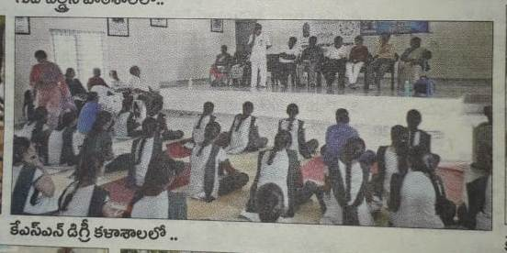
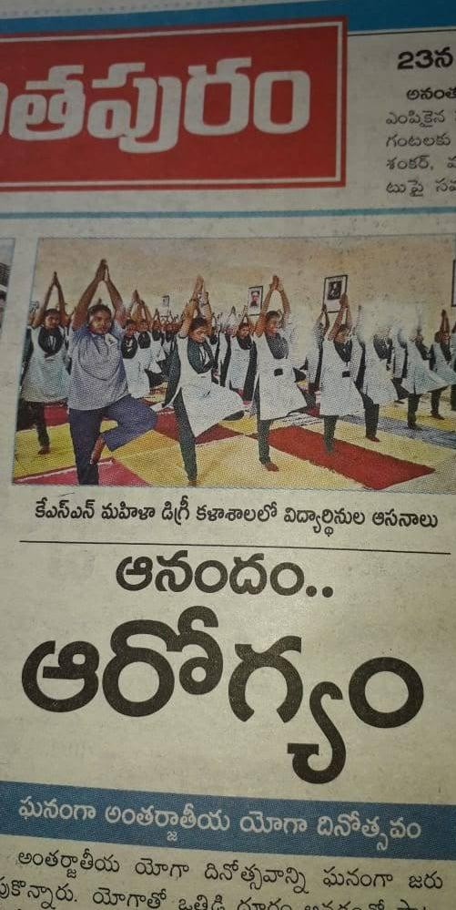
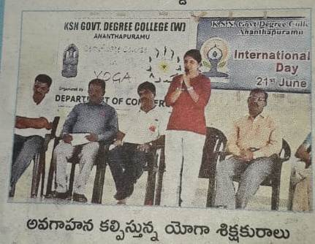

OBSERVED INTERNATIONAL DAY AGAINST DRUG ABUSE AND
ILLICIT TRAFFICKING ON 26.06.2019
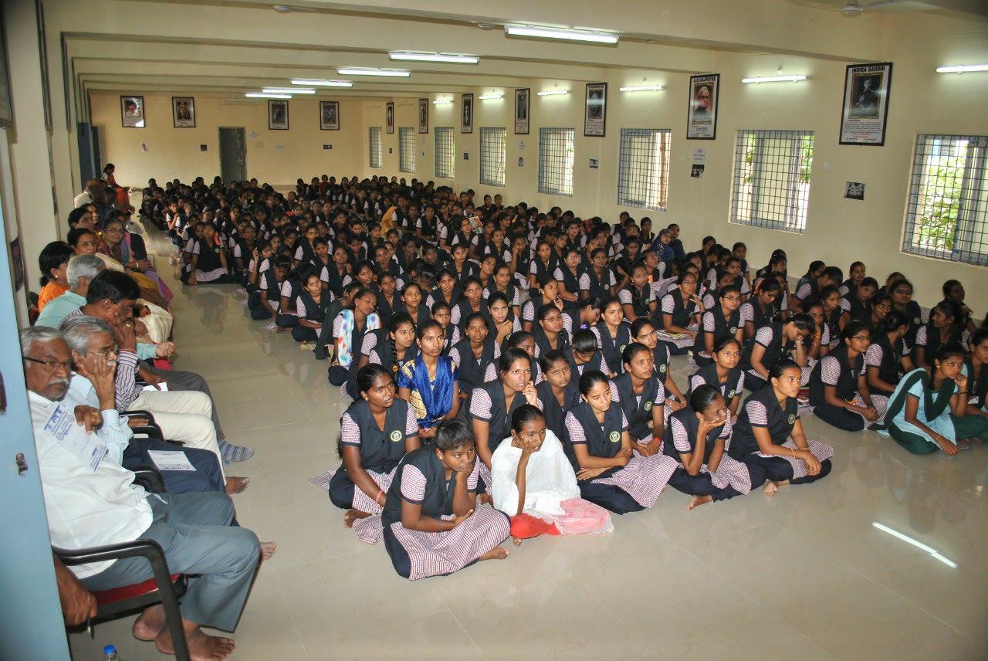

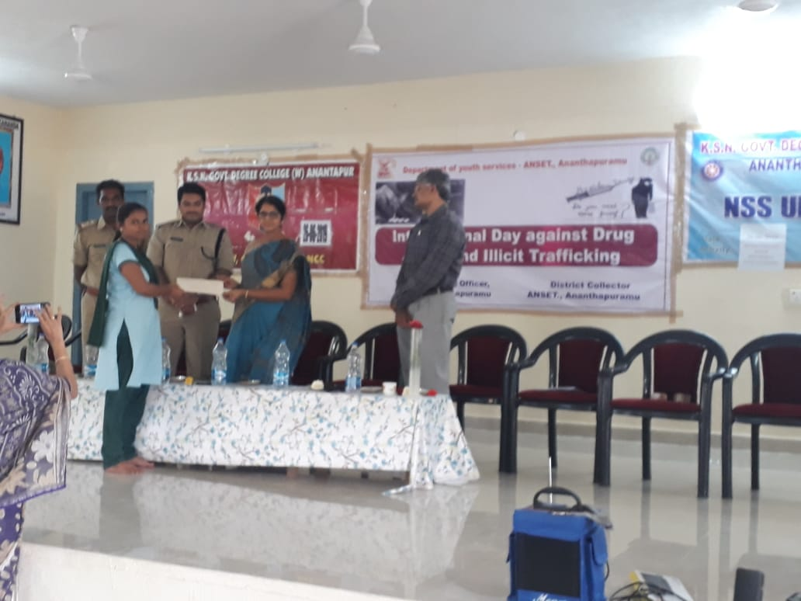
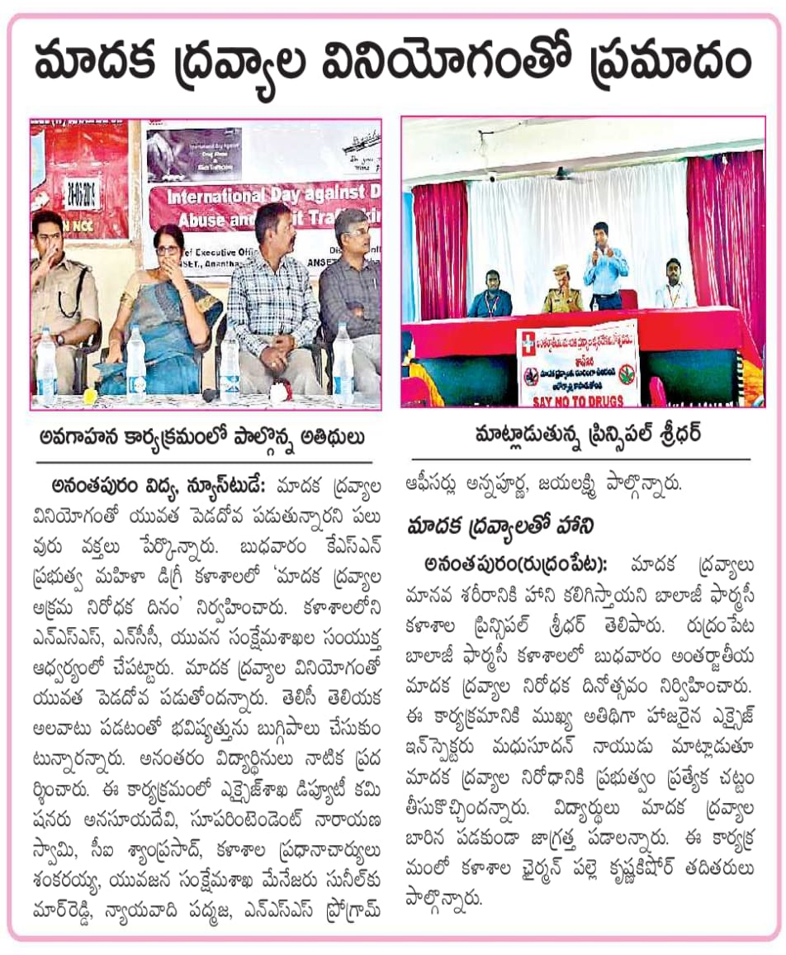
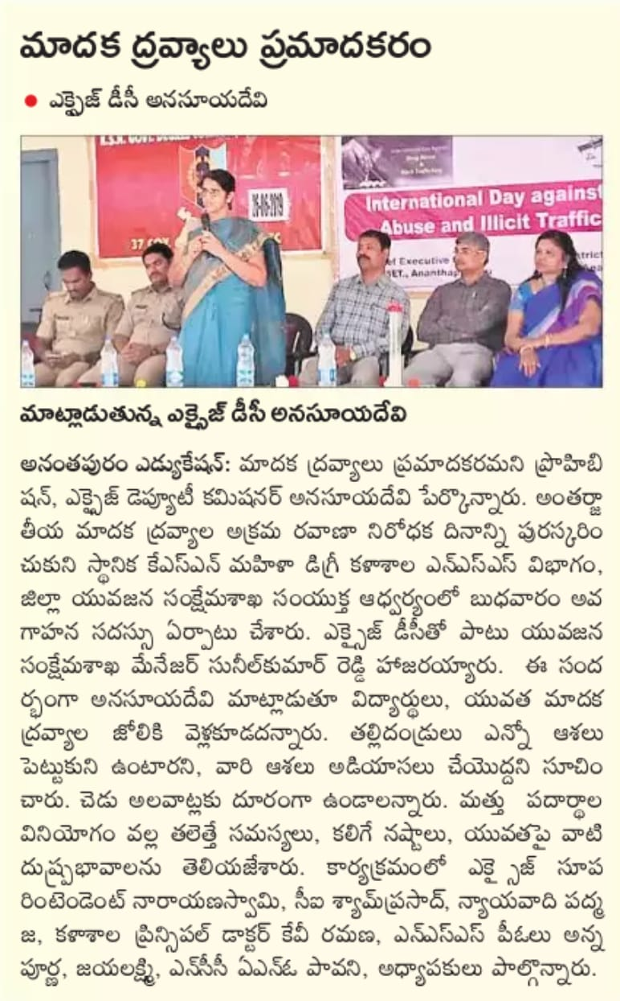
PARTICIPATED IN NATIONAL INTEGRATION CAMP IN KURNOOL FROM 16.07.2019 TO 20.07.2019

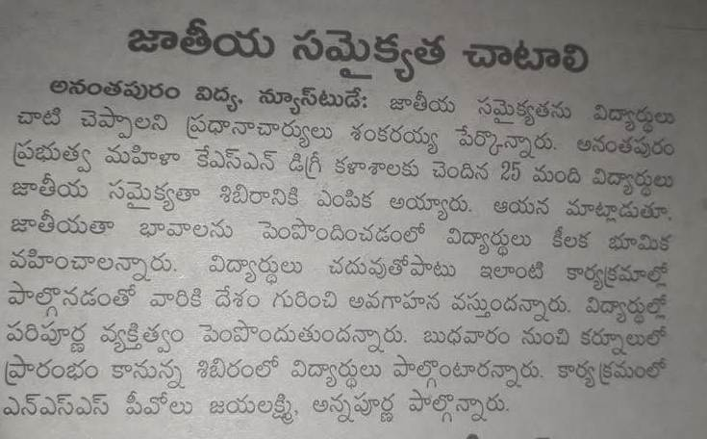
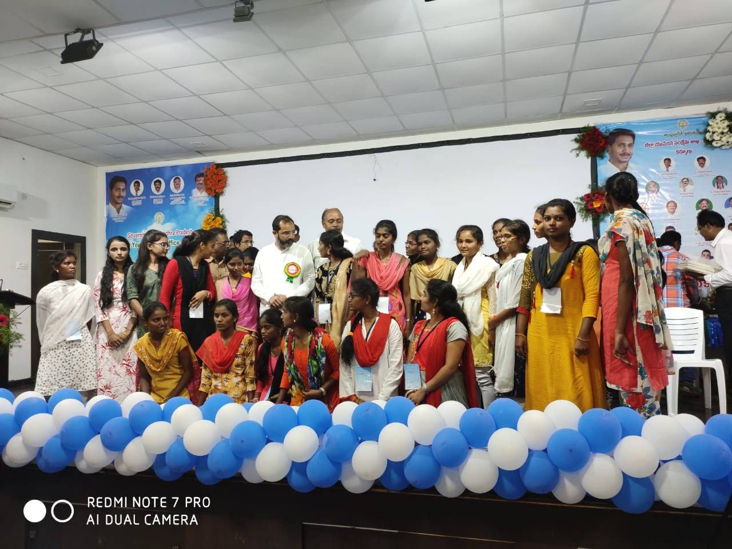
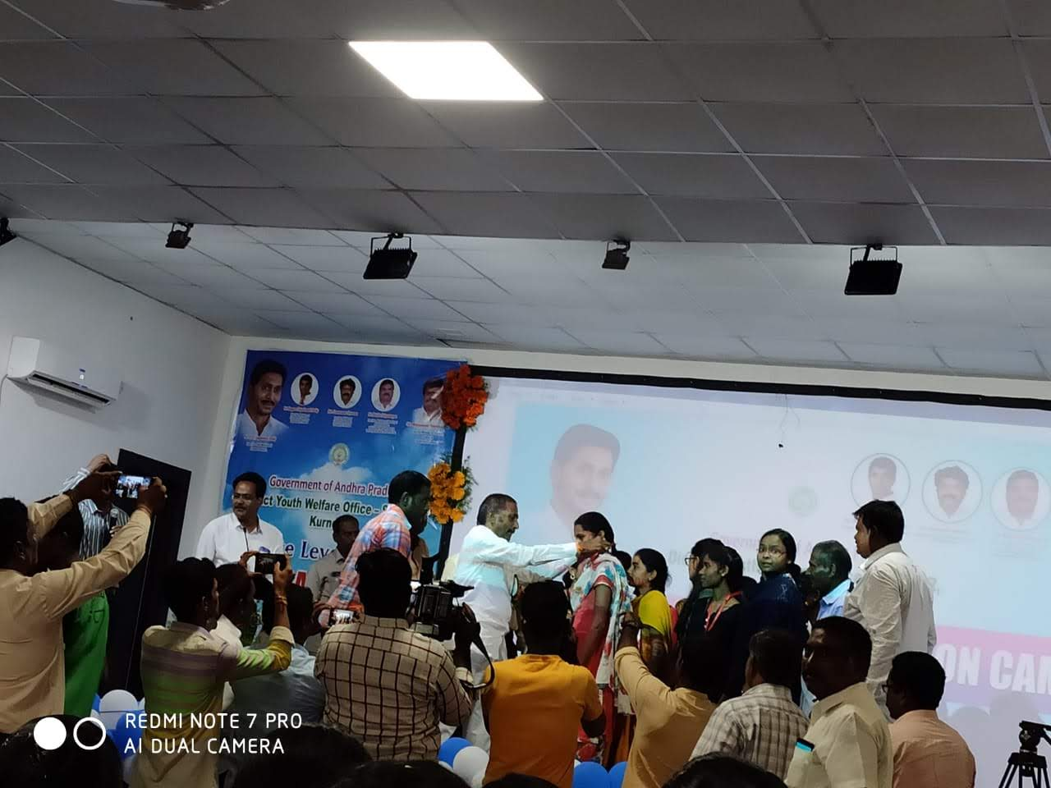
CELEBRATED WORLD POPULATION DAY 0N 11.07.2019
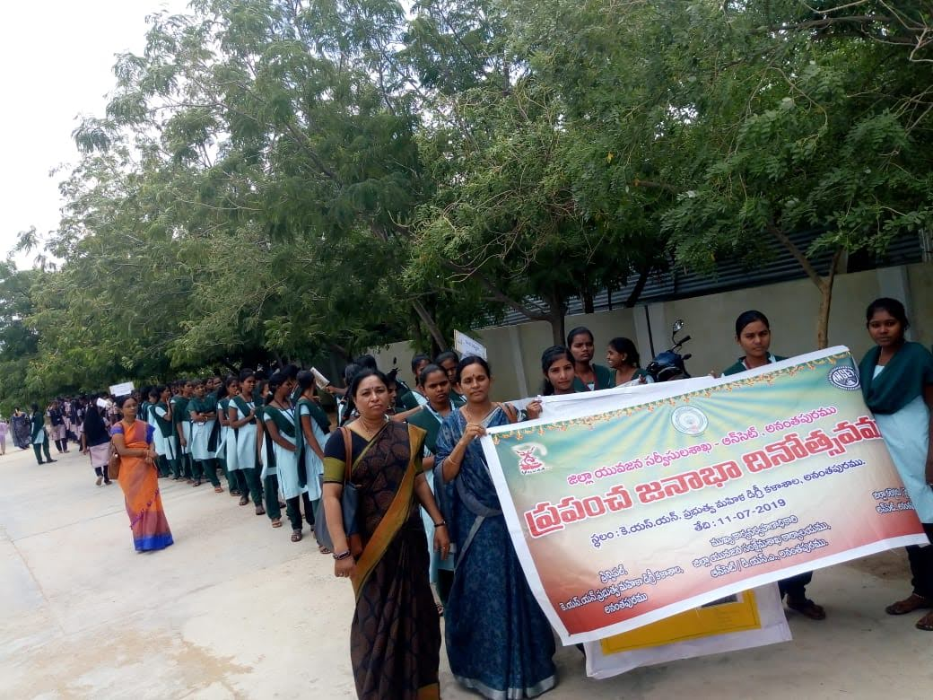
CONDUCTED RALLY WITH STUDENTS
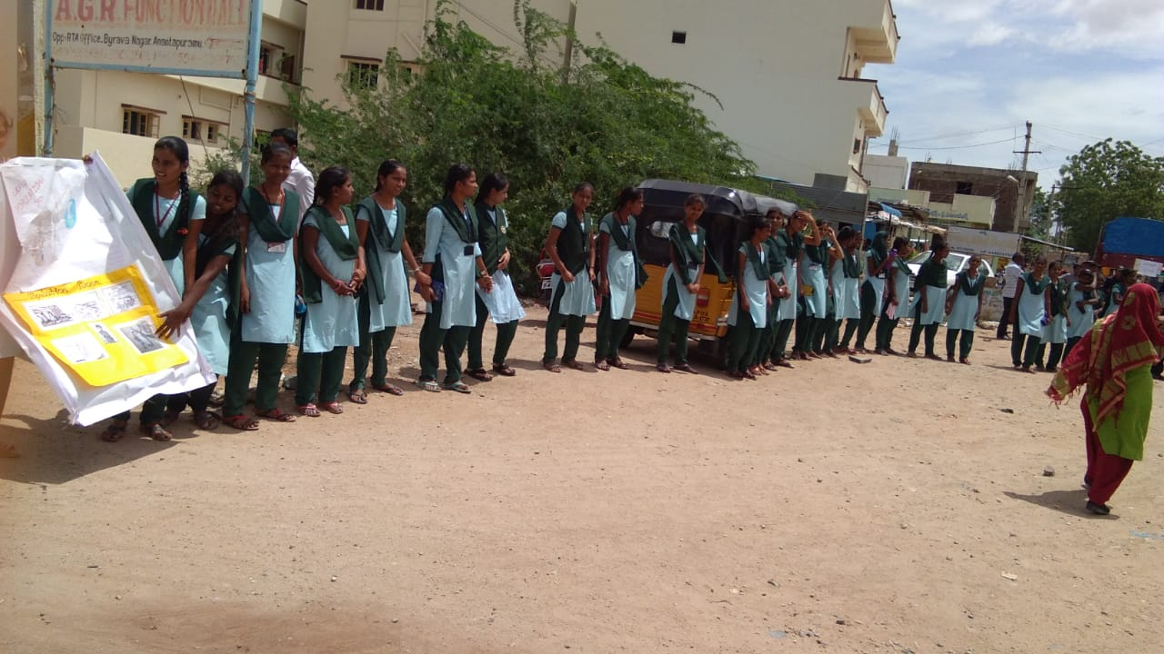
DISTRIBUTED DEWORMING TABLETS ON THE OCCASION OF NATIONAL DEWORMING DAY ON 08.08.2019
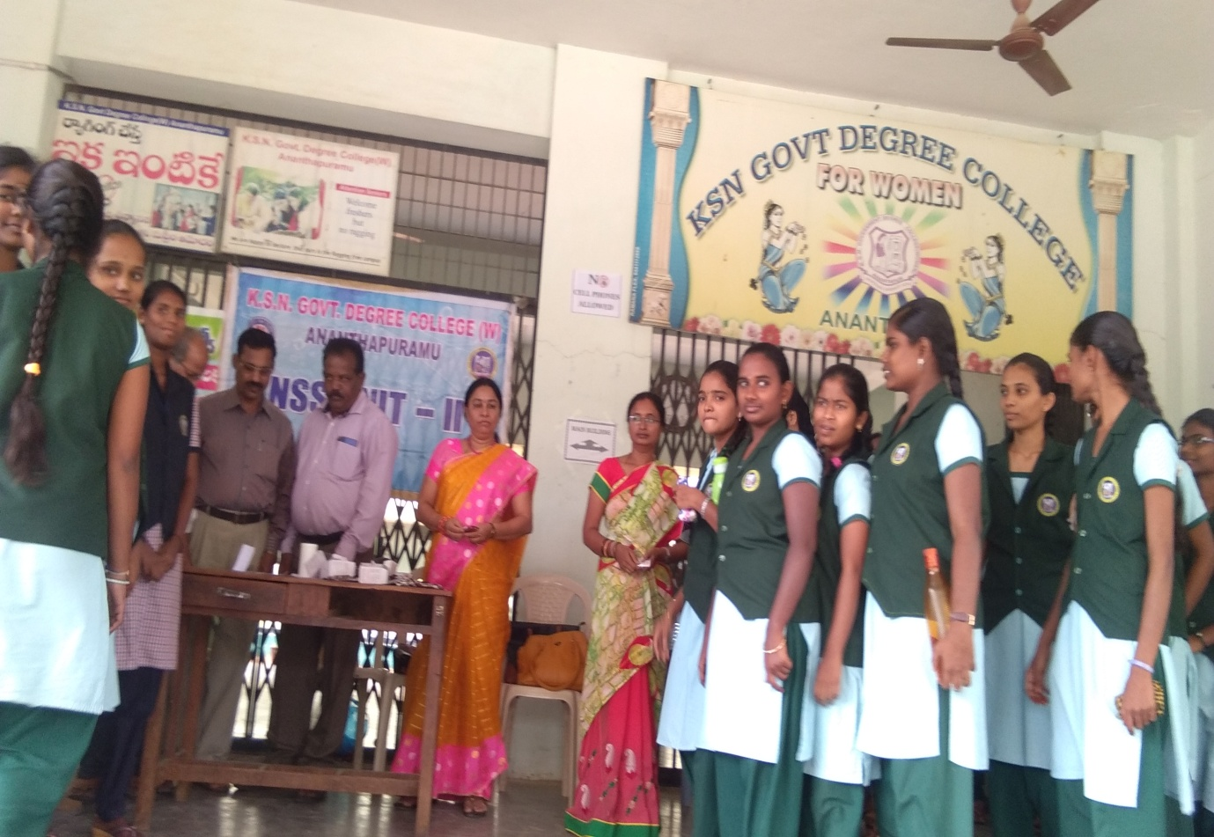
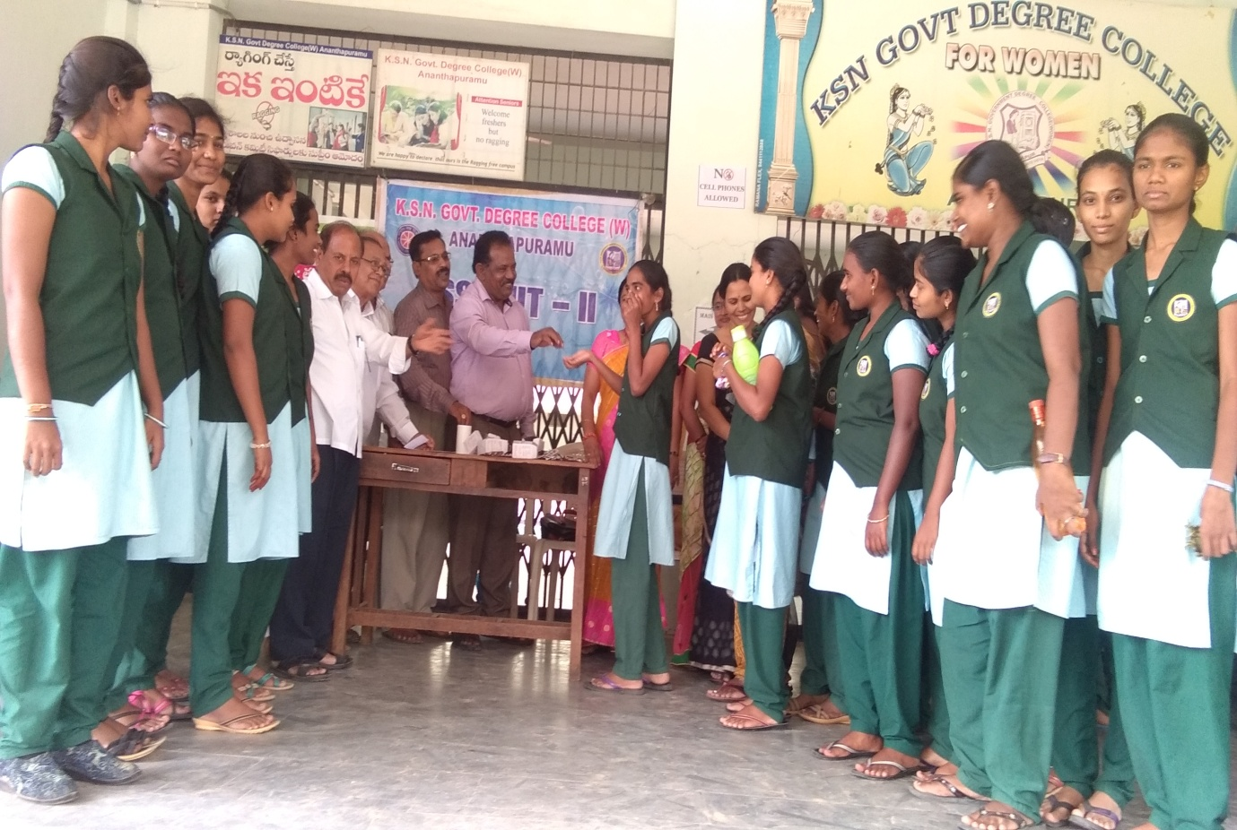
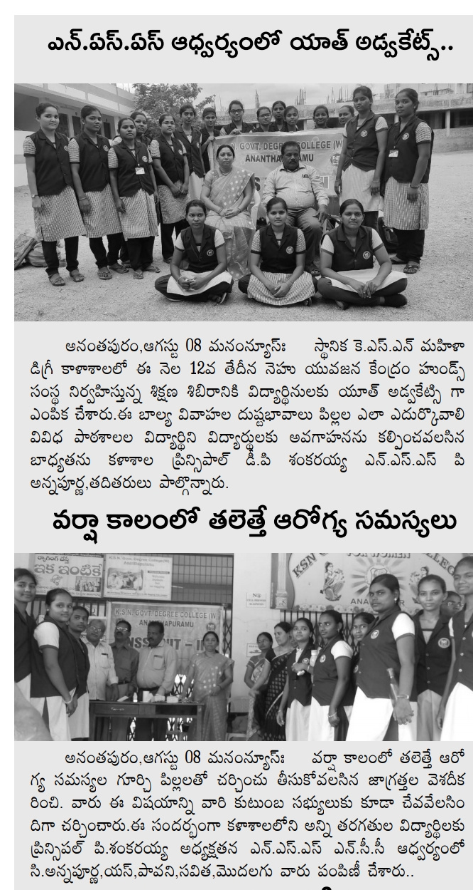
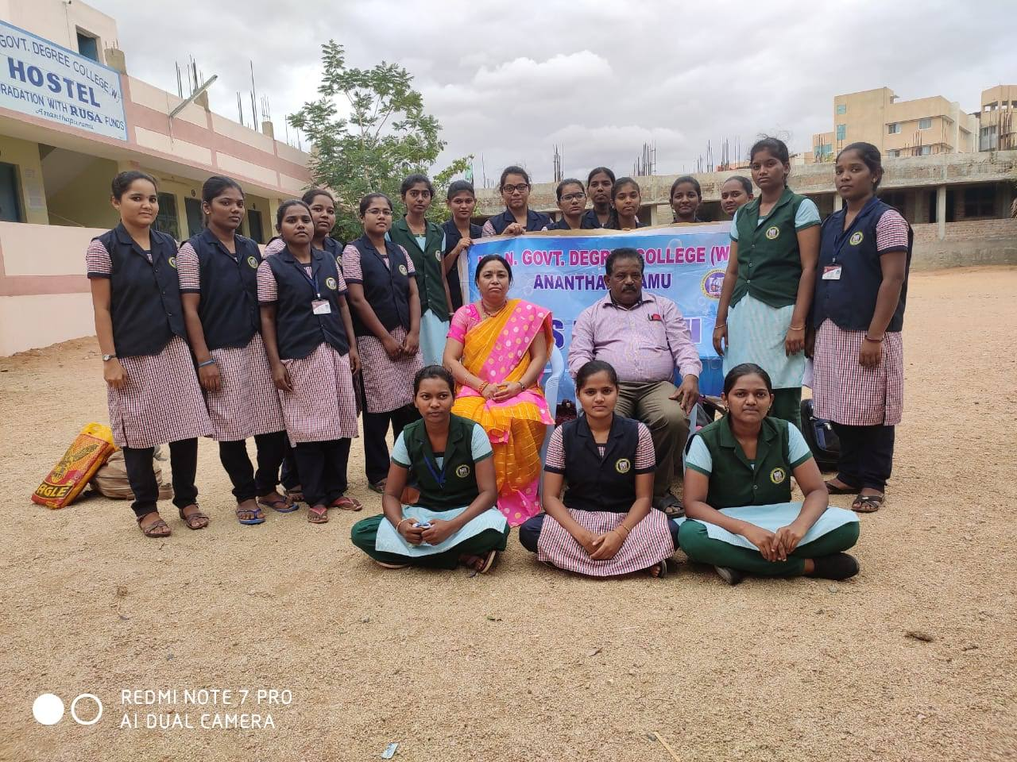
PLANTATION OF TREES ON THE OCCASION OF
INDEPENDENCE DAY 15.08.2019
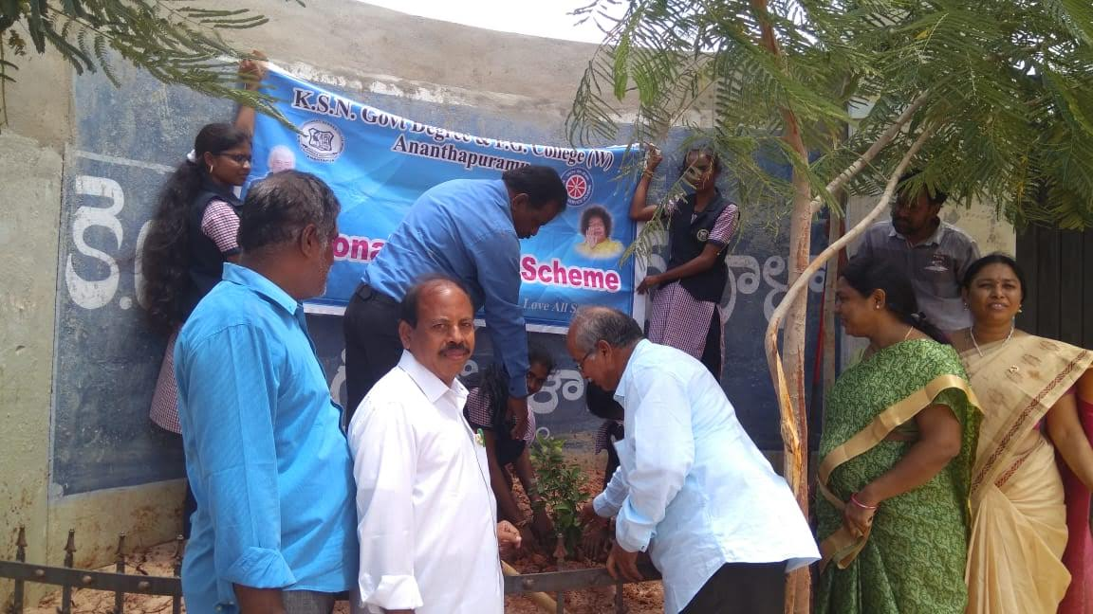
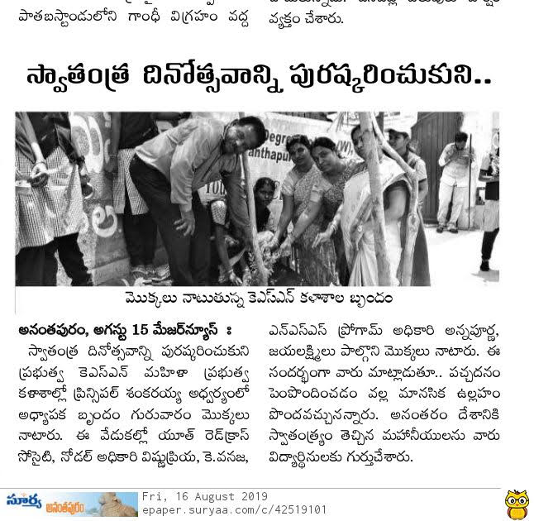
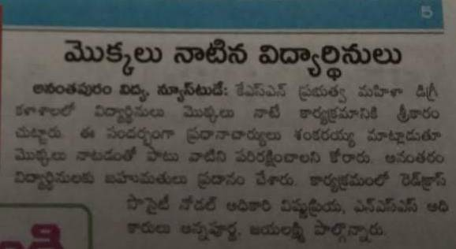

AWARENESS PROGRAMME CONDUCTED BY AIMSS ABOUT WOMEN’S RIGHTS ON 23.08.2019
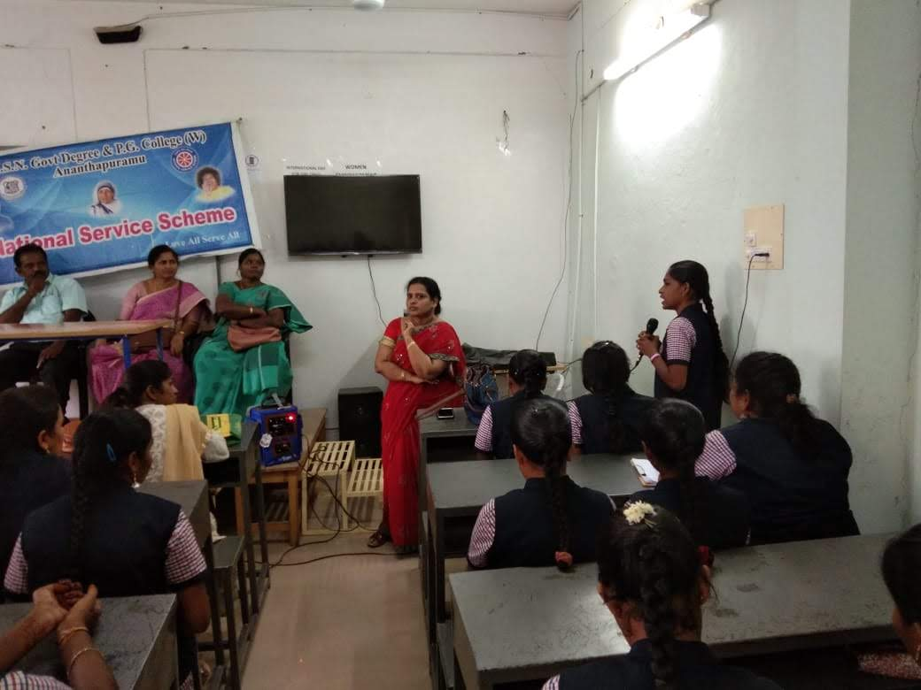
CELEBRATED NSS DAY GOLDEN JUBILEE CELEBRATIONS ON 05.10.2019
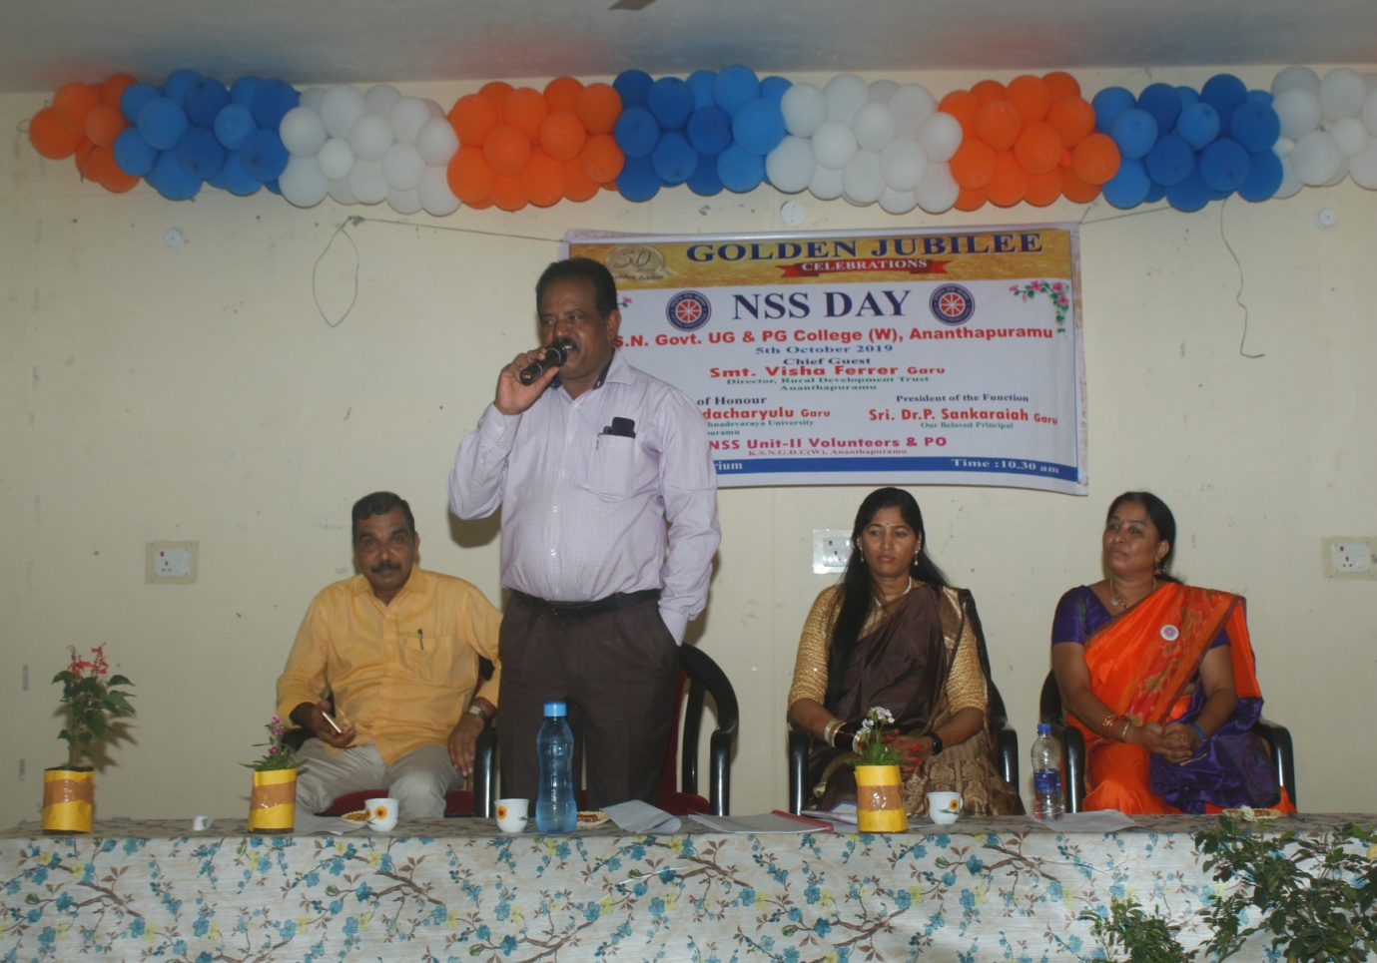
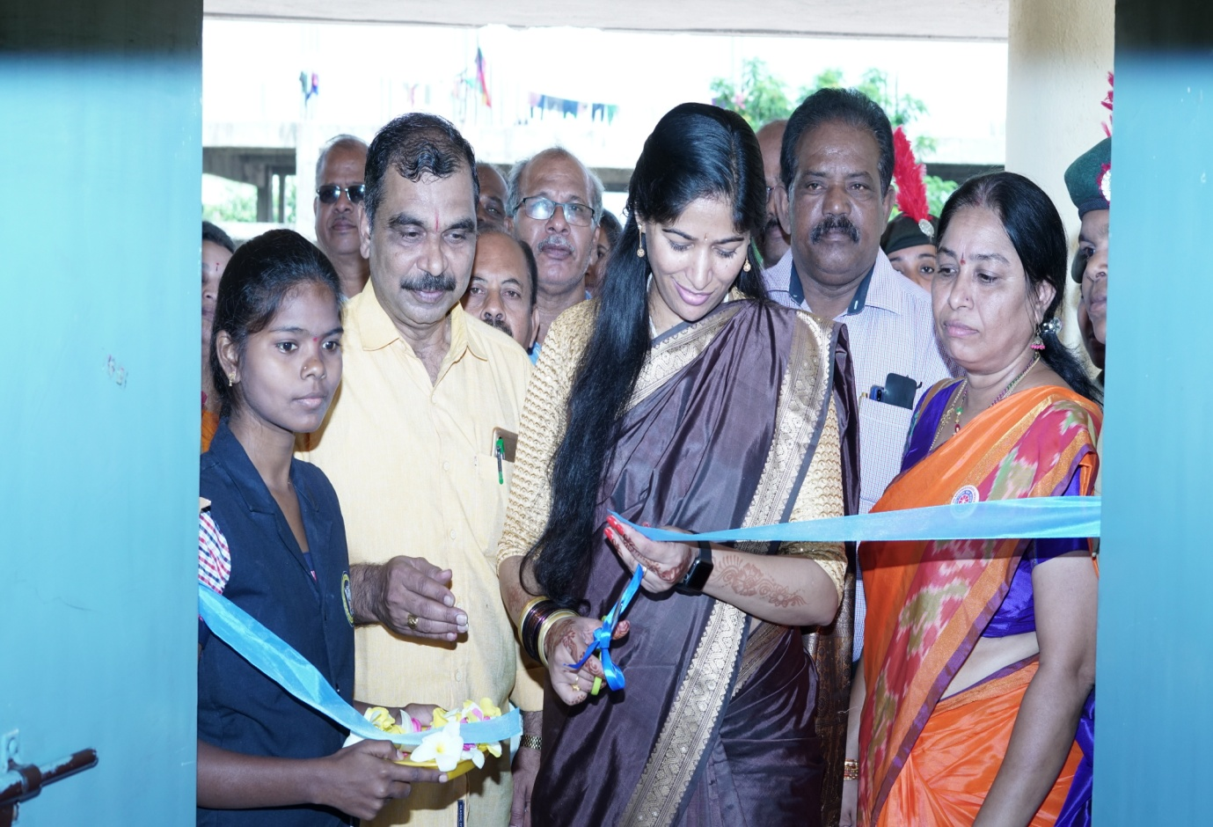
ARRANGED POSTER EXHIBITION ON QUOTATIONS ON SERVICE MOTTOS
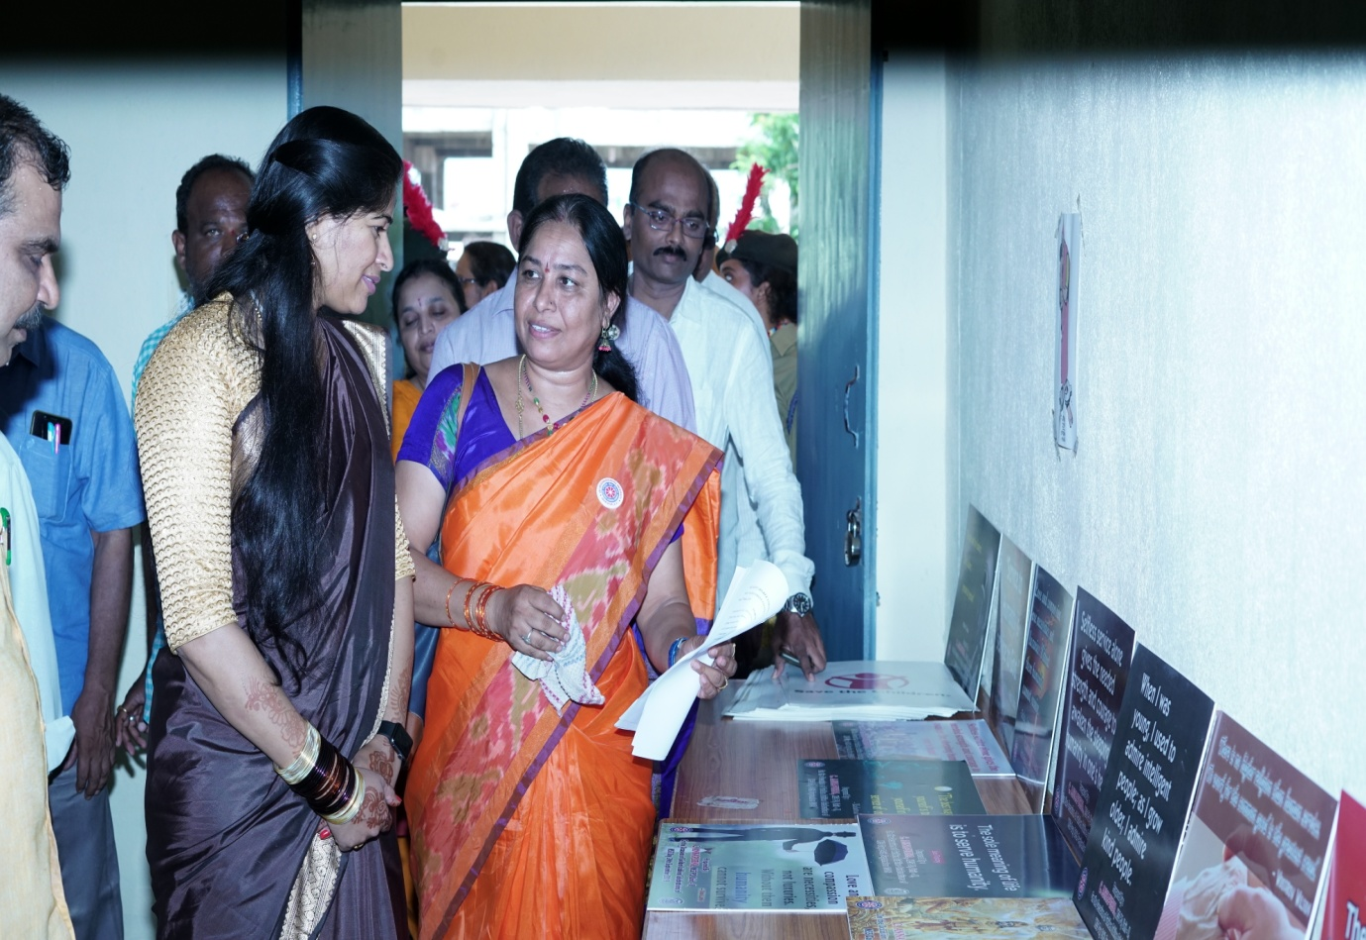
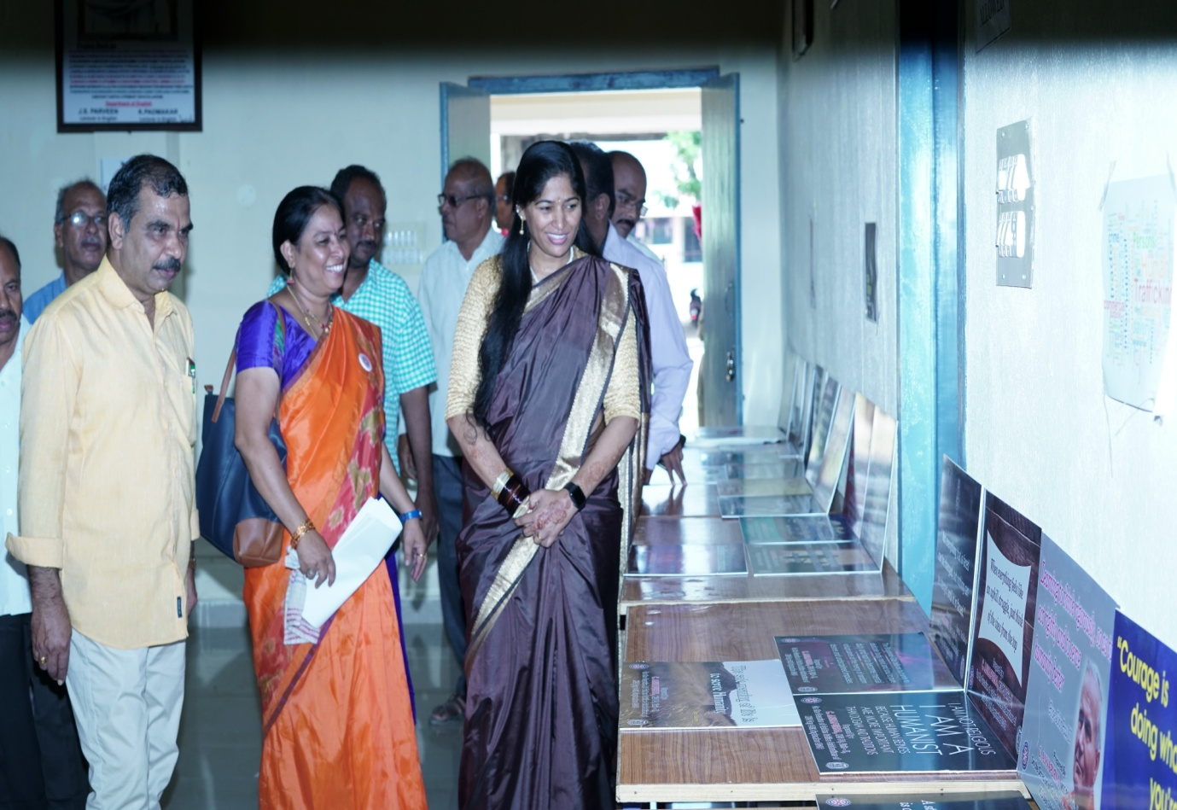
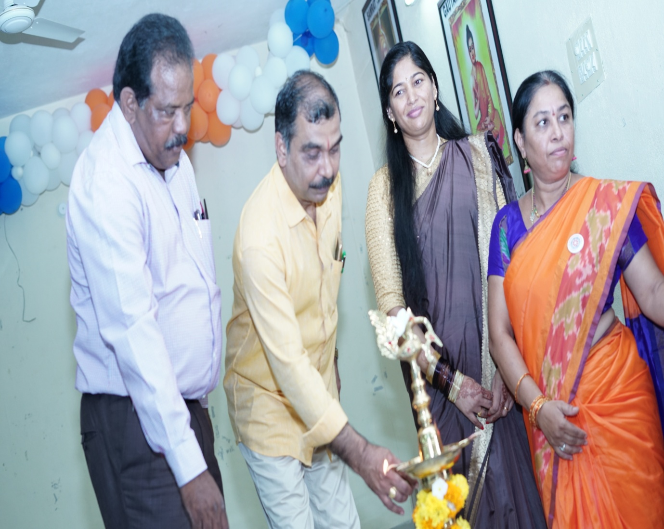
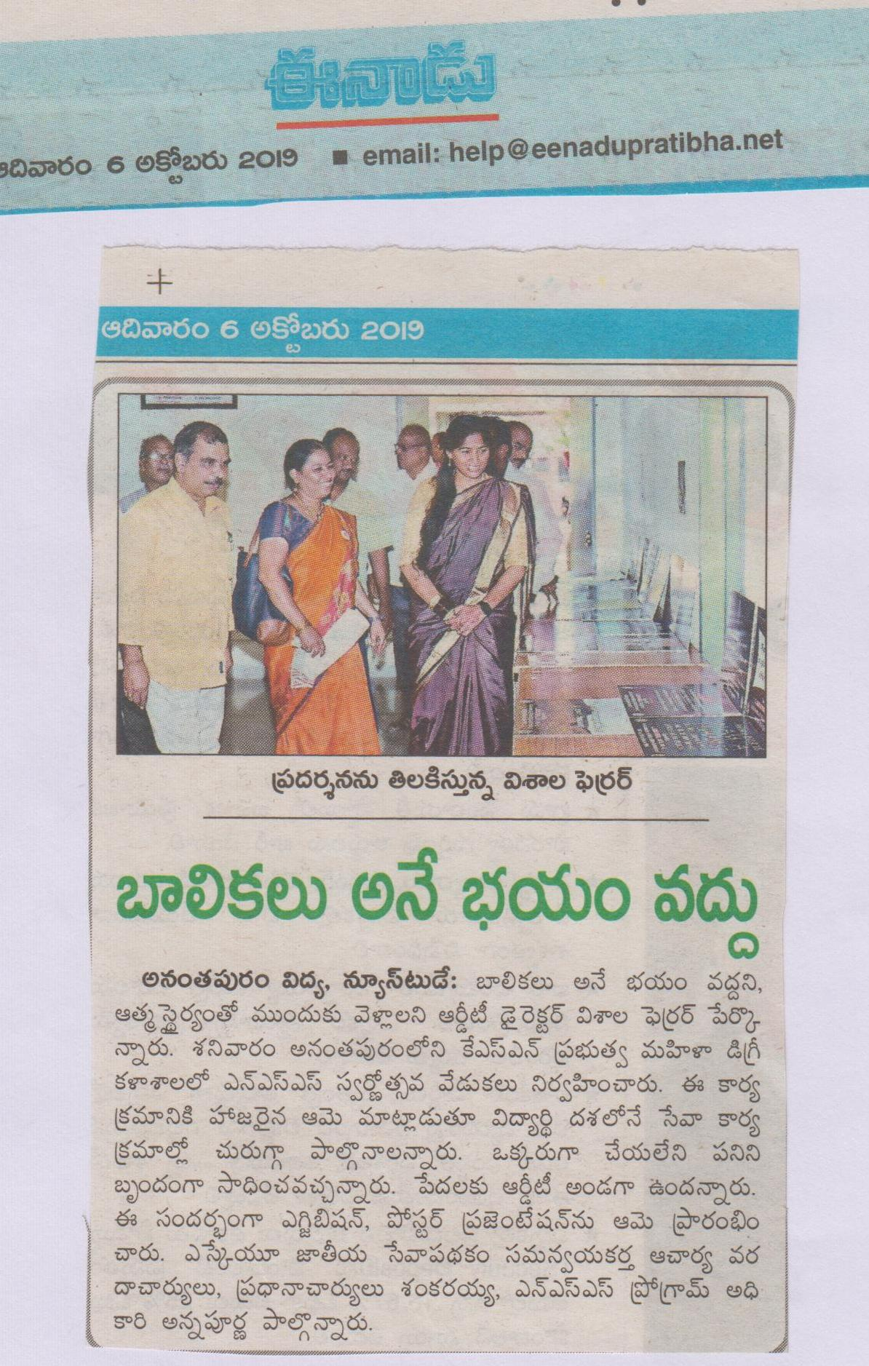

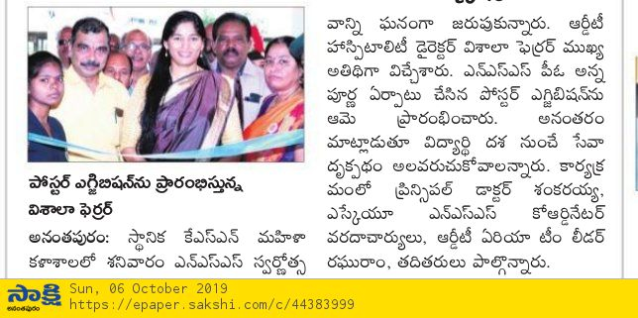
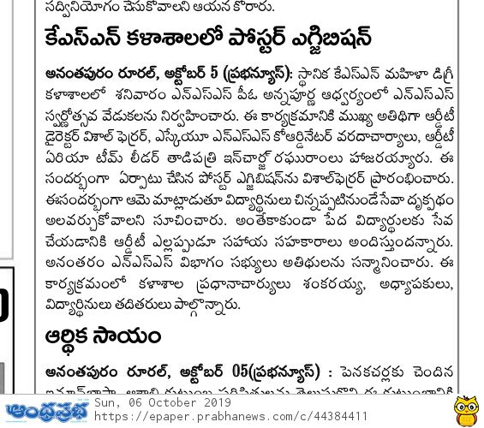
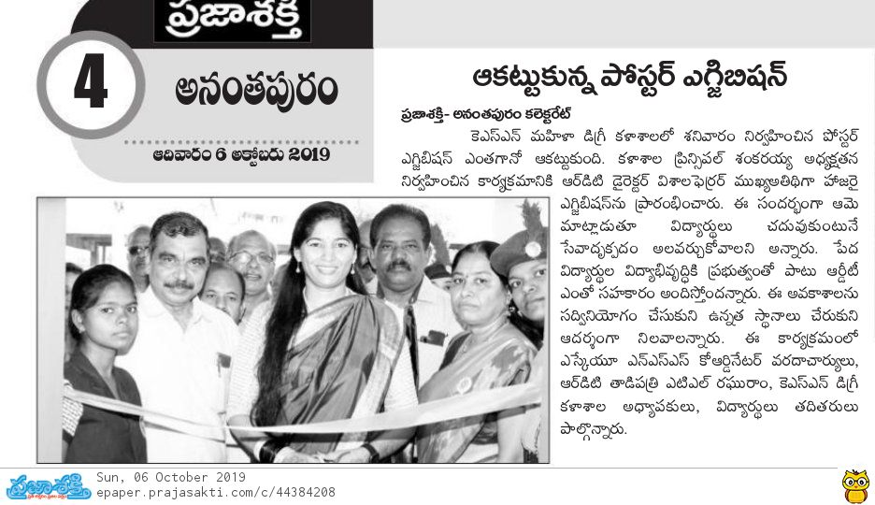
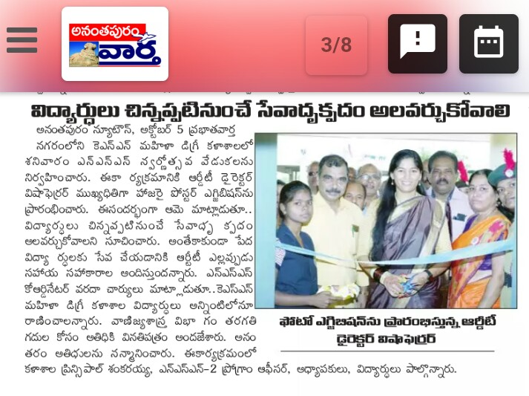
CELEBRATED GANDHI JAYANTI ON 02/10/2019
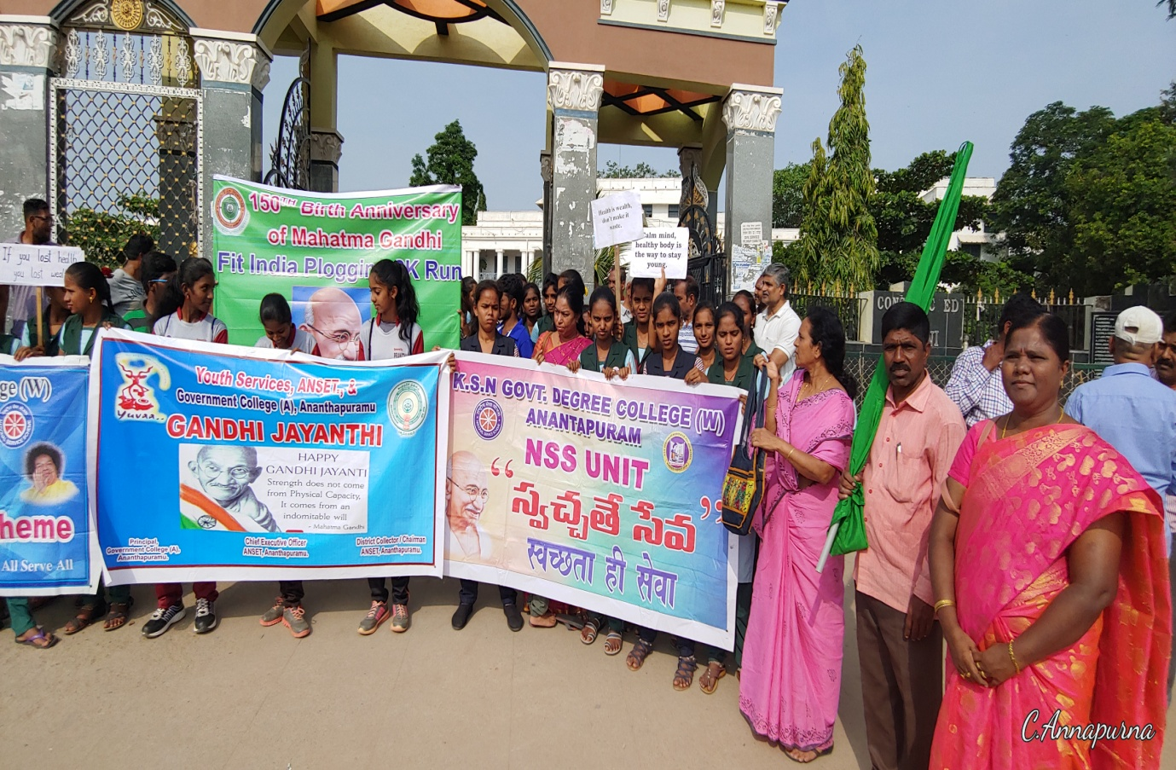
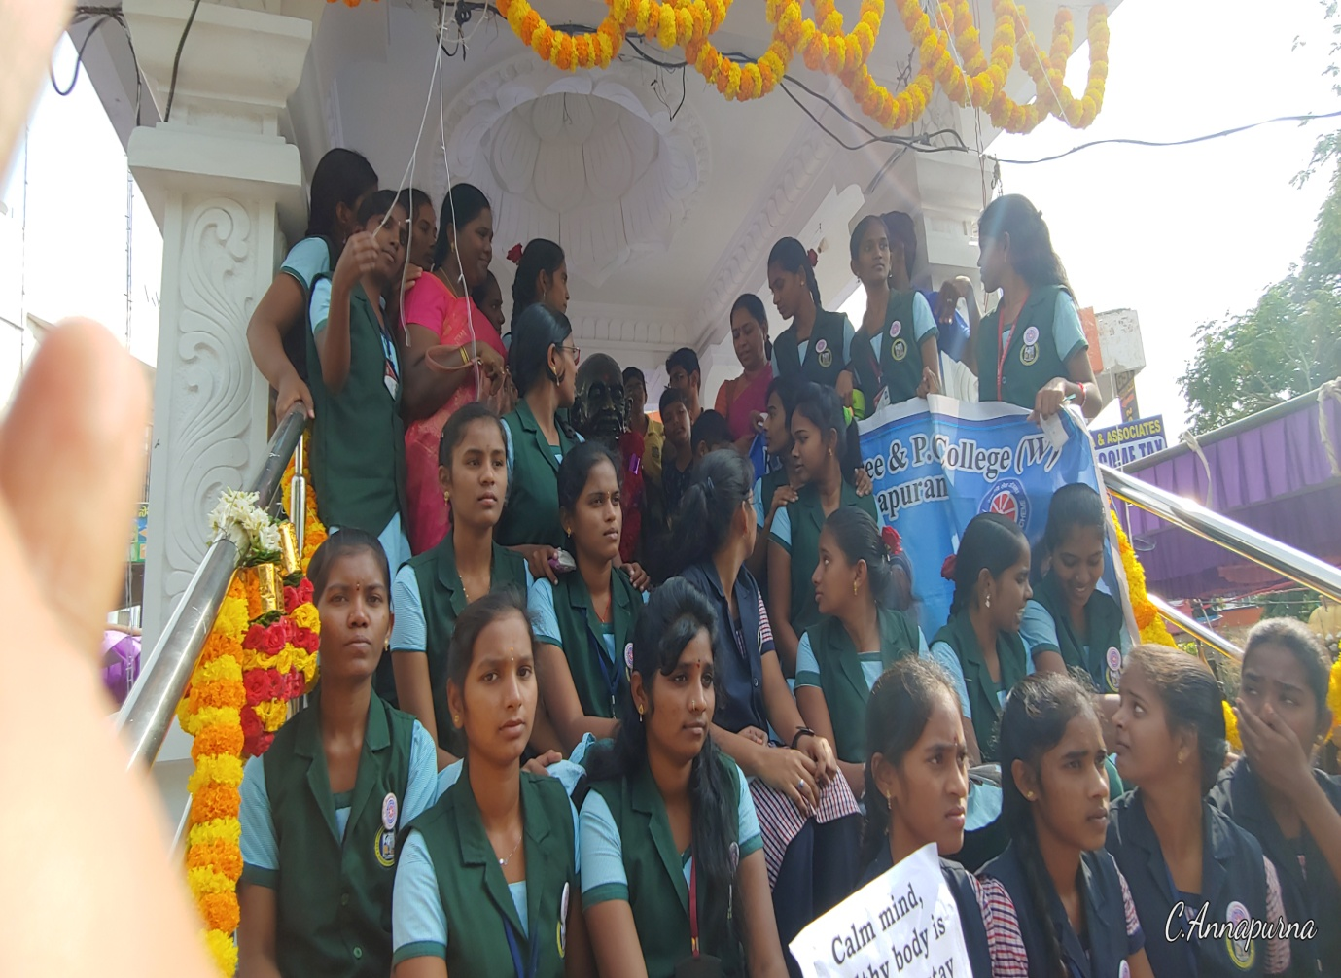
PARTICIPATED IN KISHORI VIKASAM WORKSHOP FOR PROJECT RESOURCE PERSONS ON 2/11/2019 AT R.D.T. STADIUM
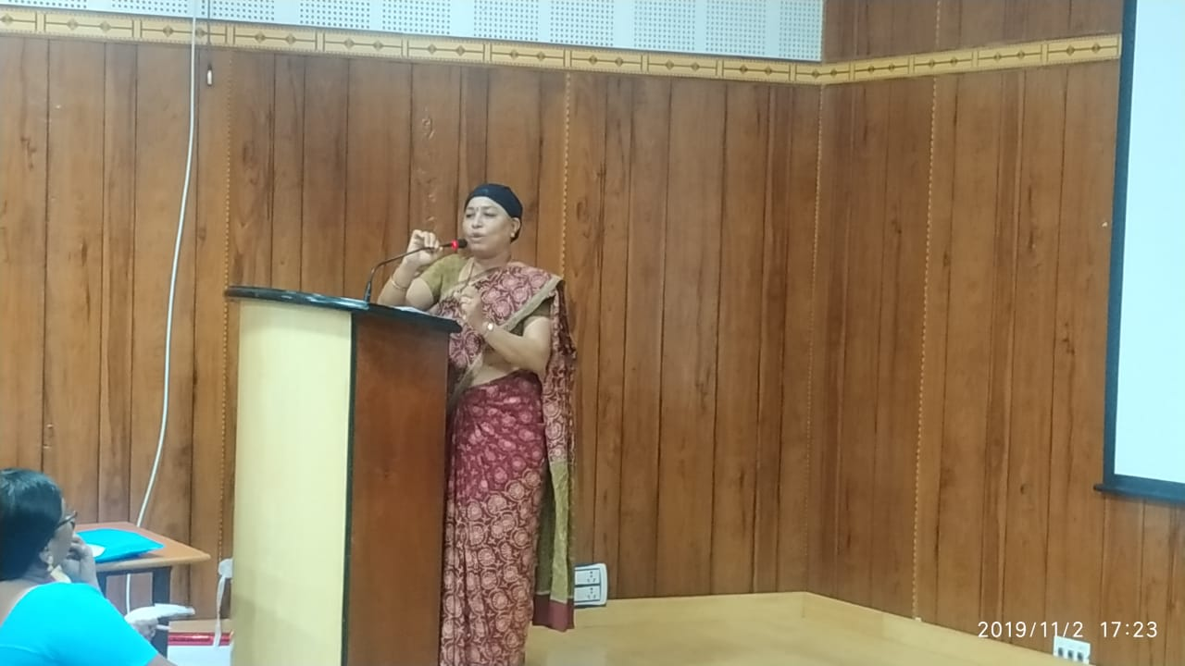
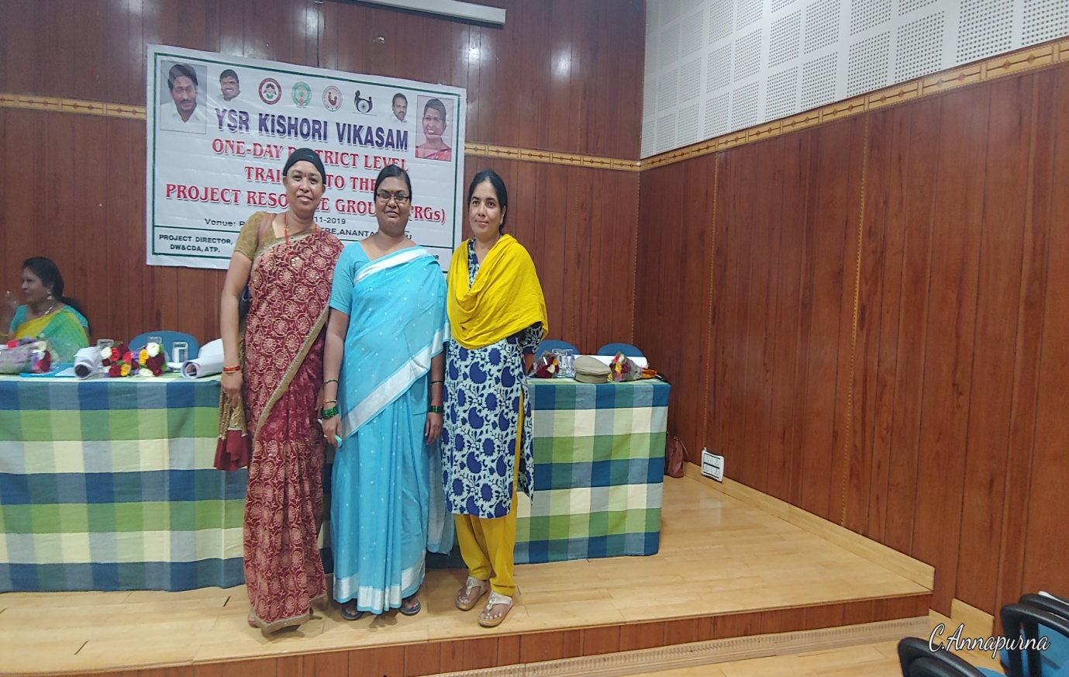

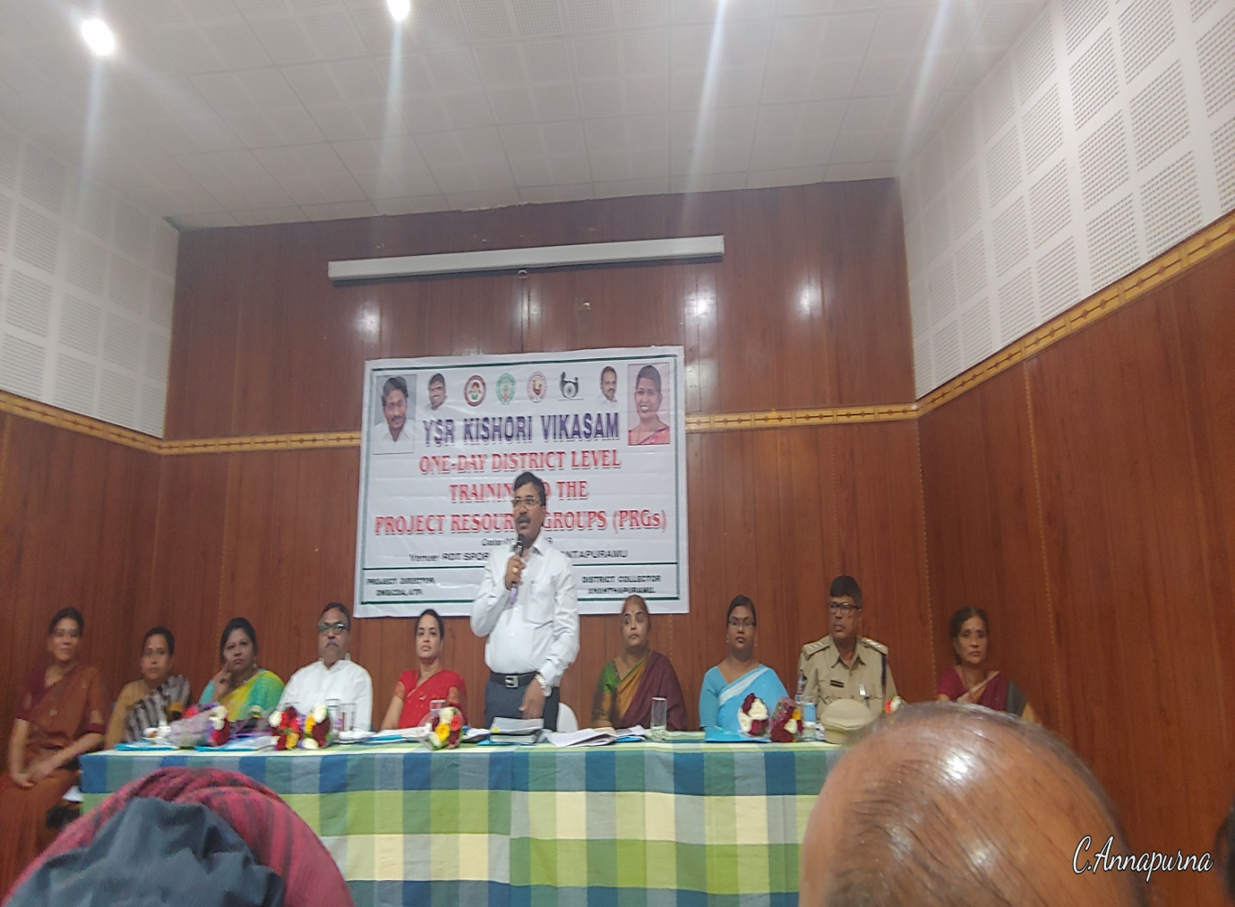
CELEBRATED NATIONAL CONSTITUTION DAY ON 25.11.2019
POWERPOINT PRESENTATION ABOUT FUNDAMENTAL DUTIES
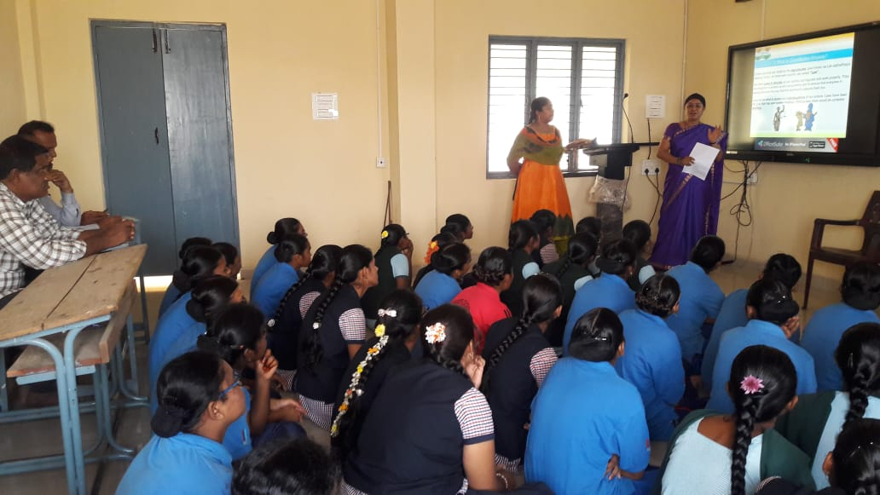
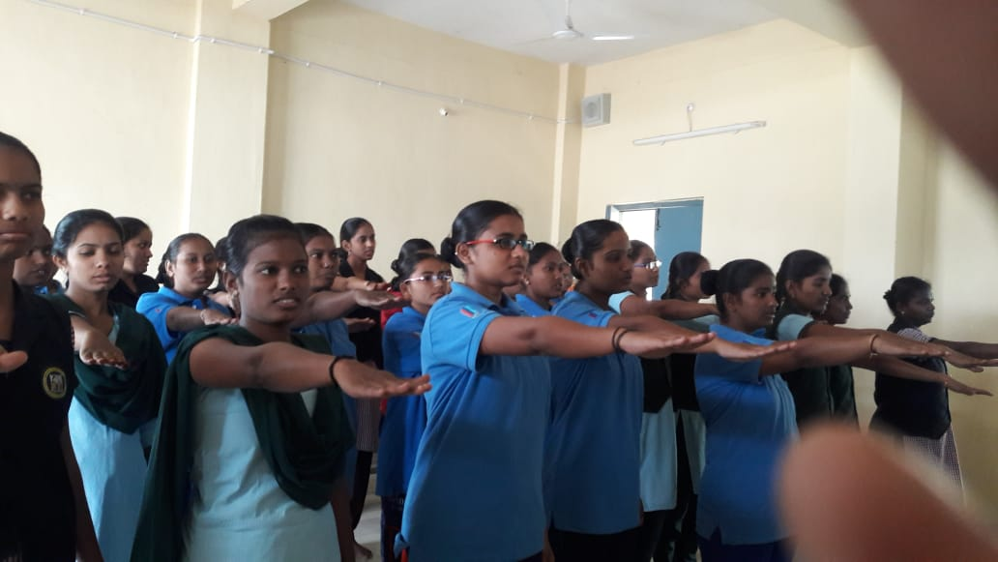
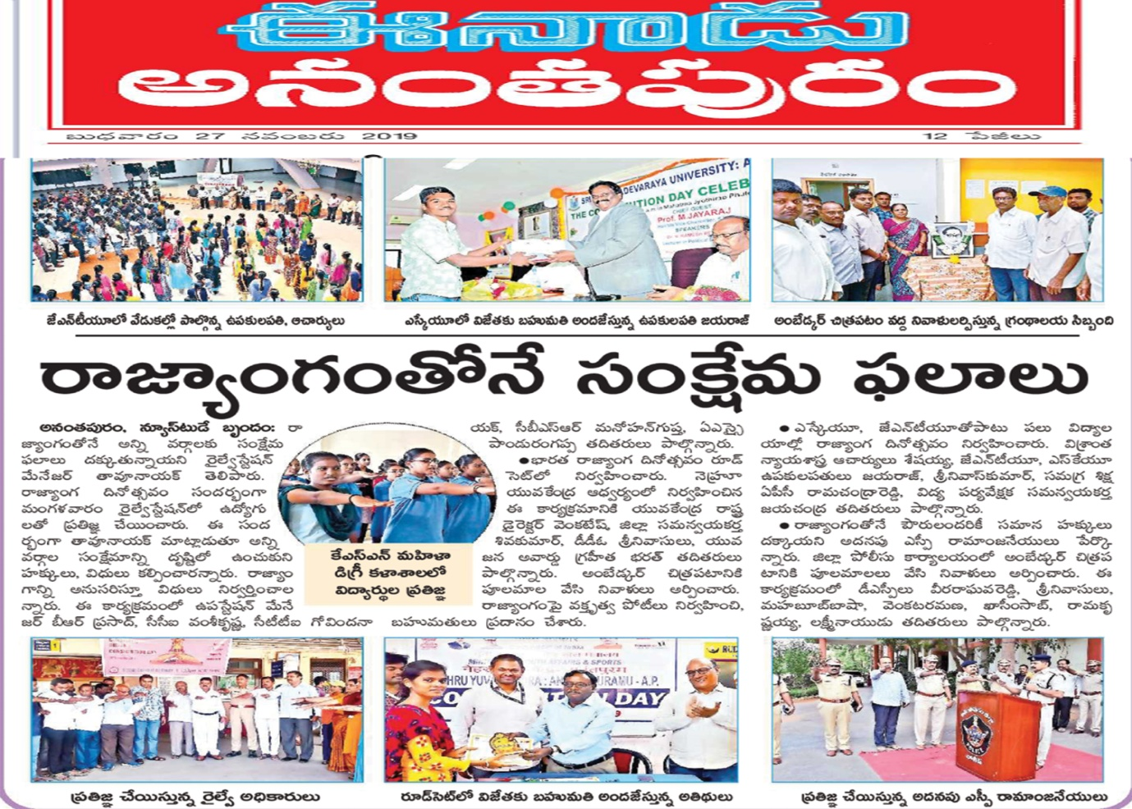
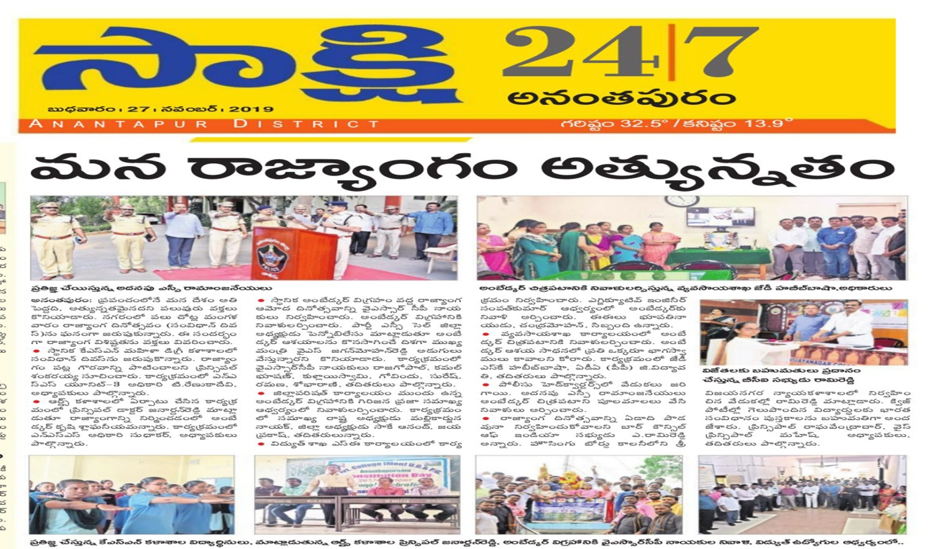

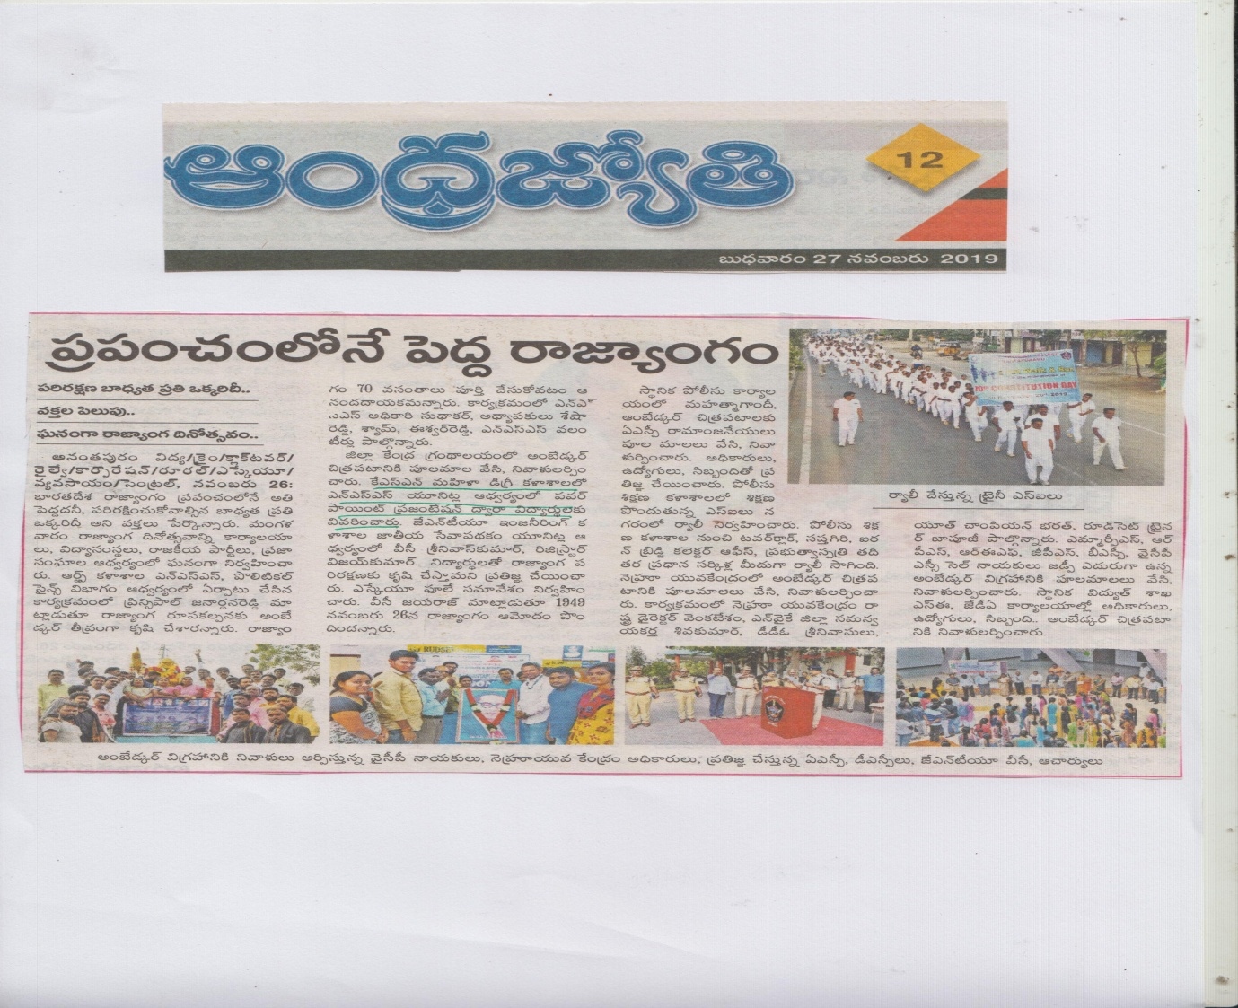
PARTICIPATED IN WORLD AIDS DAY RALLY 01/12/2019
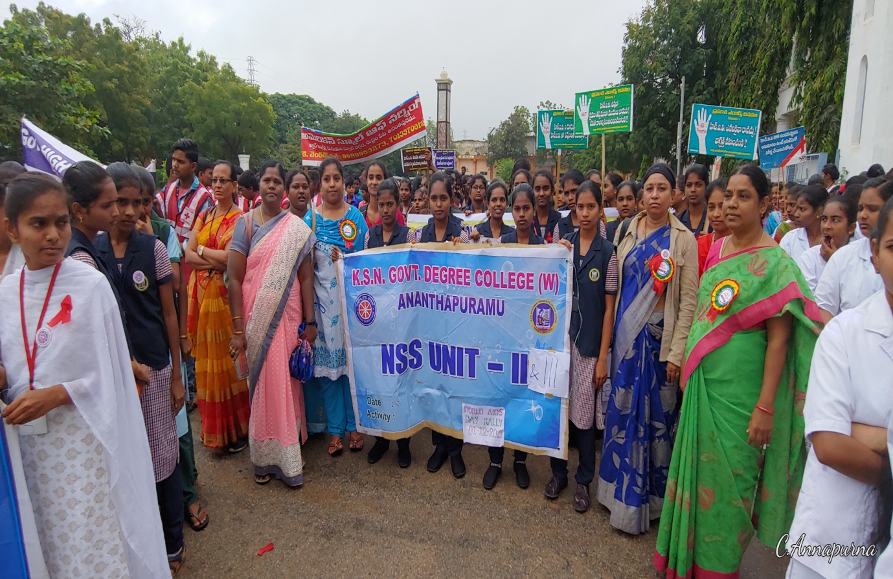
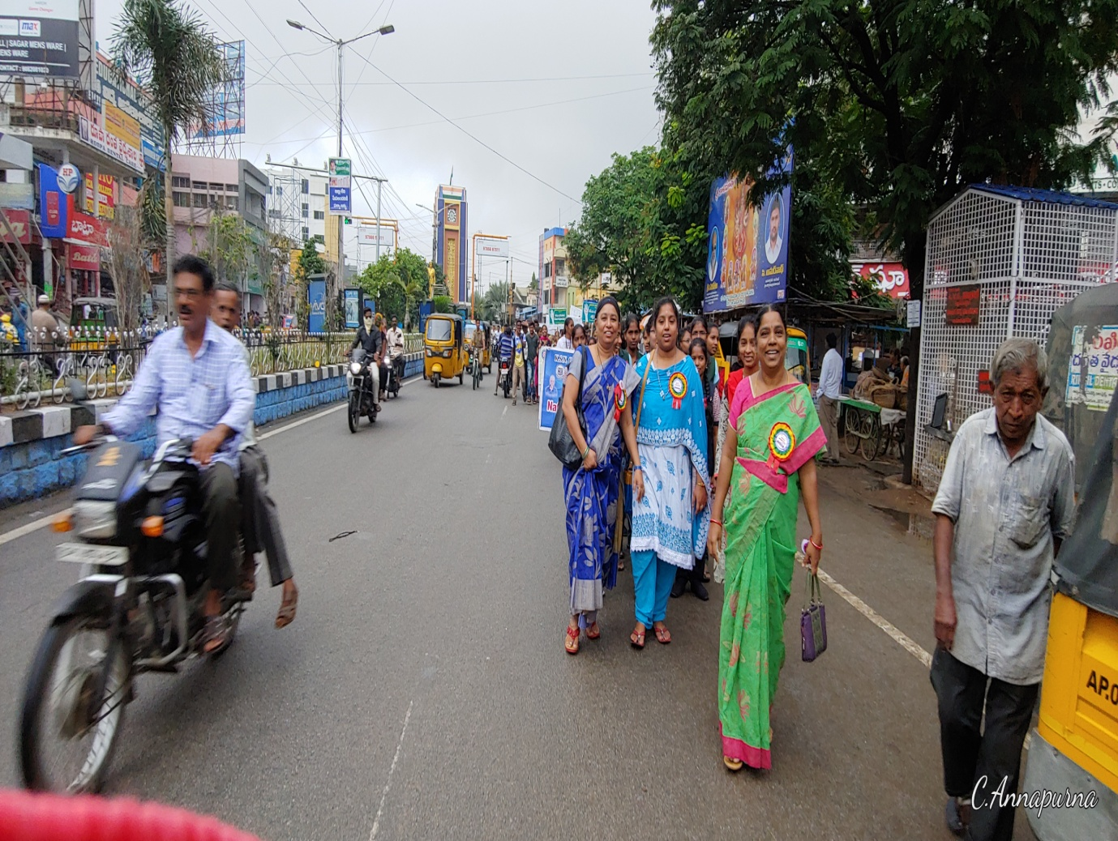
PARTICIPATPED IN THE MEETING ON YSR KISHORI VIKASAM AT JNTU AUDITORIUM ON 08/11/2019
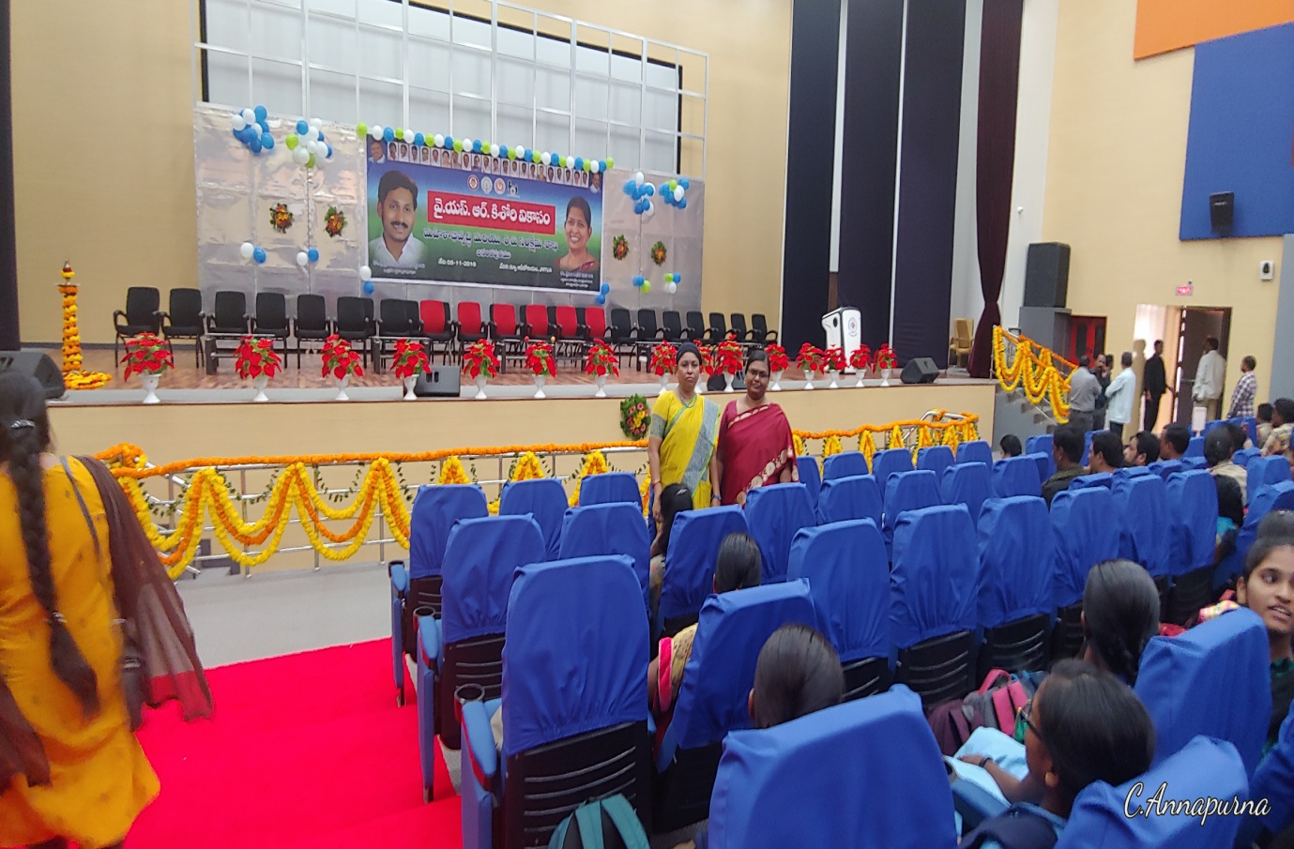
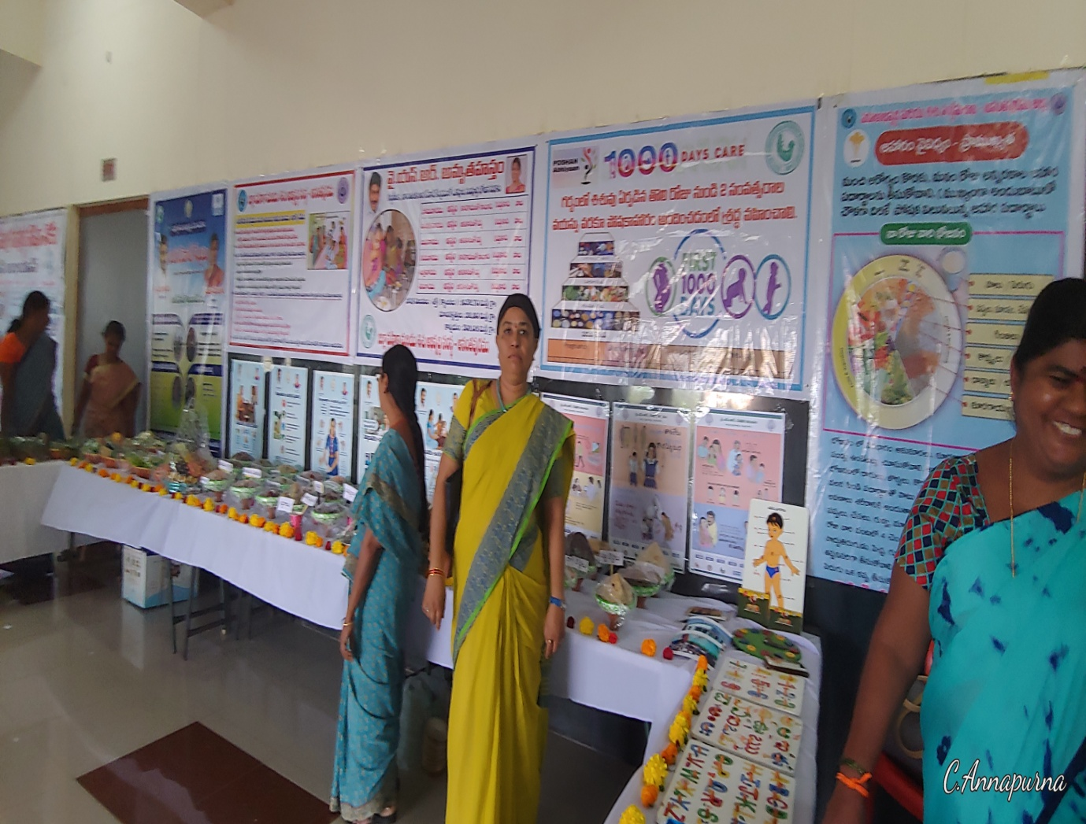
PARTICIPATED IN 3 DAY WORKSHOP FOR NSS POs ON CHILD RIGHTS AT NIPCCD, BANGALORE

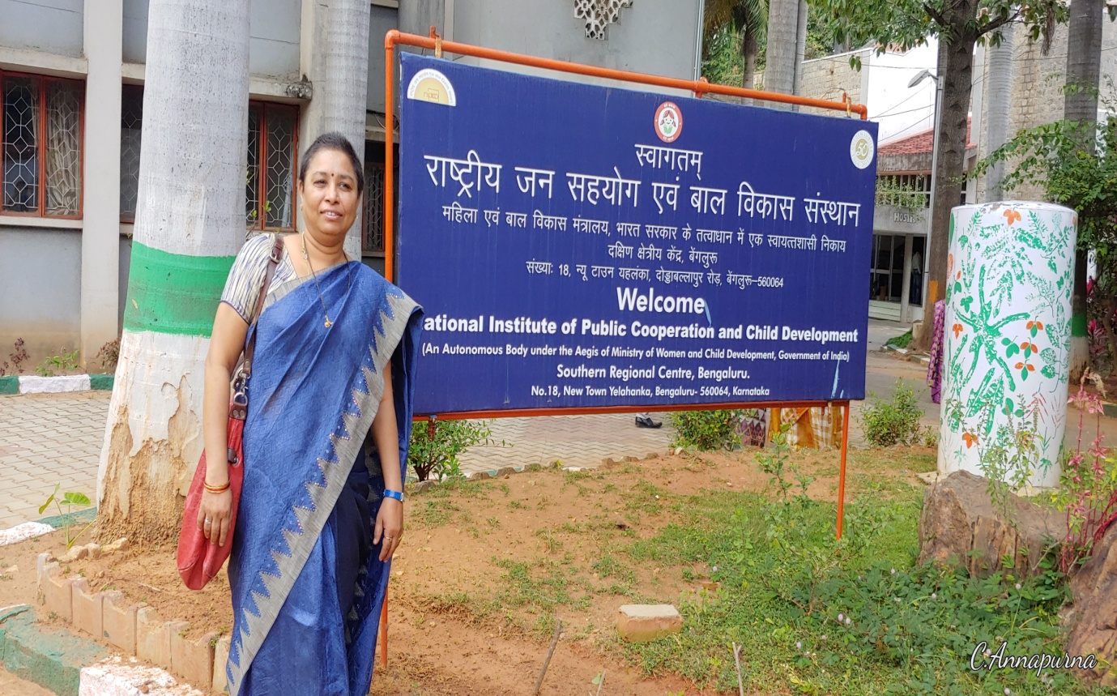
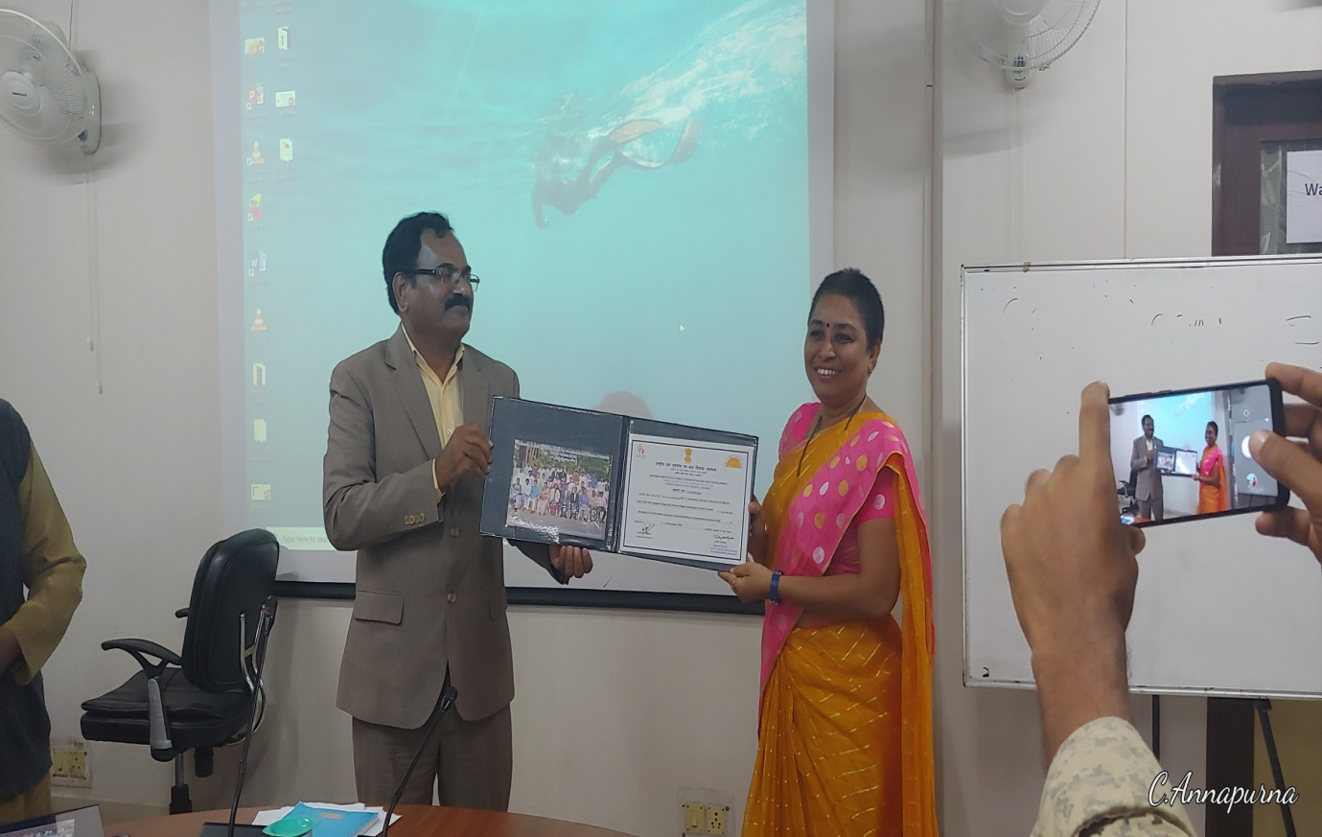
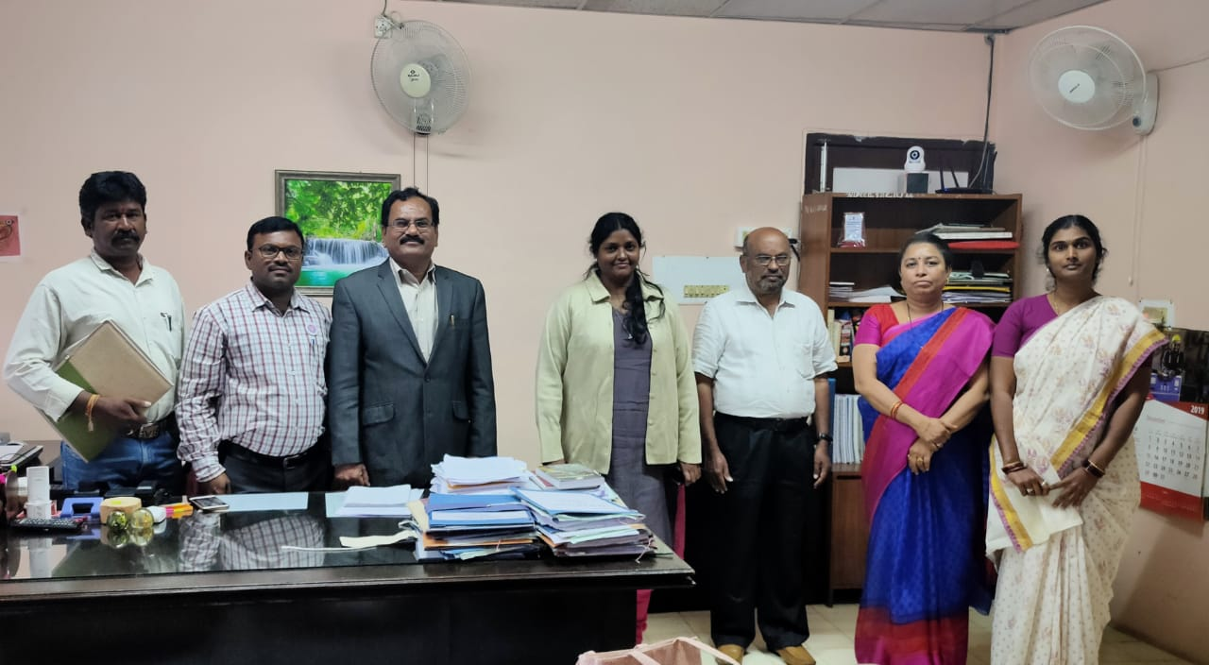
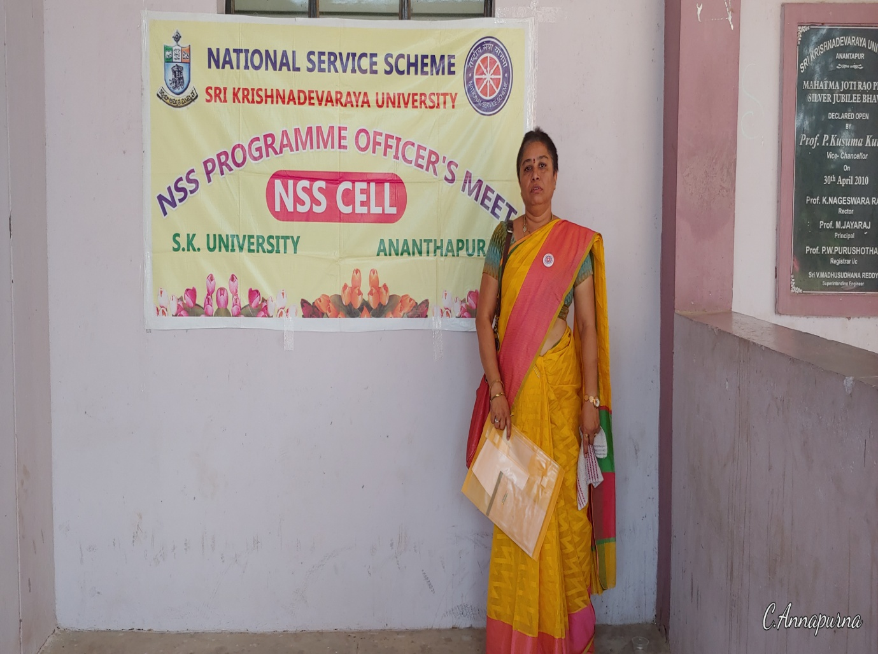
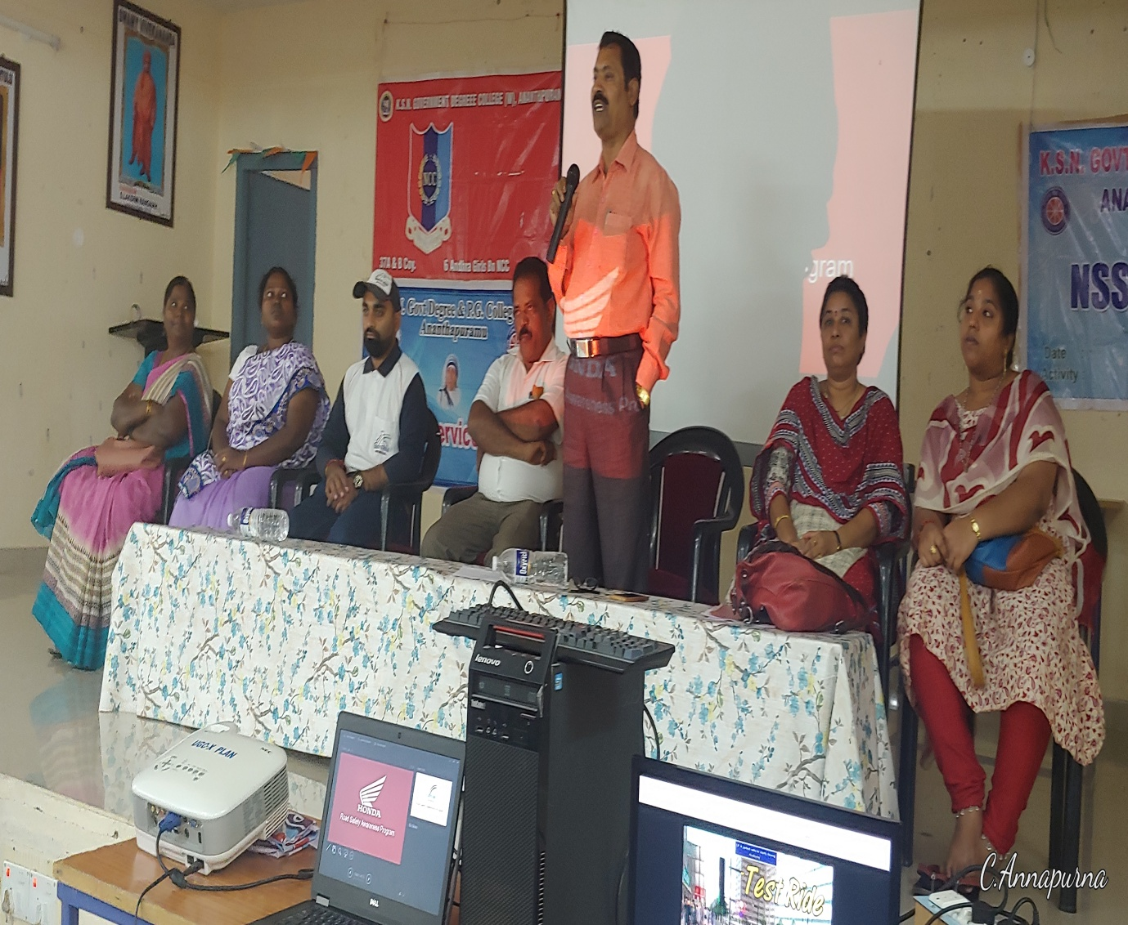
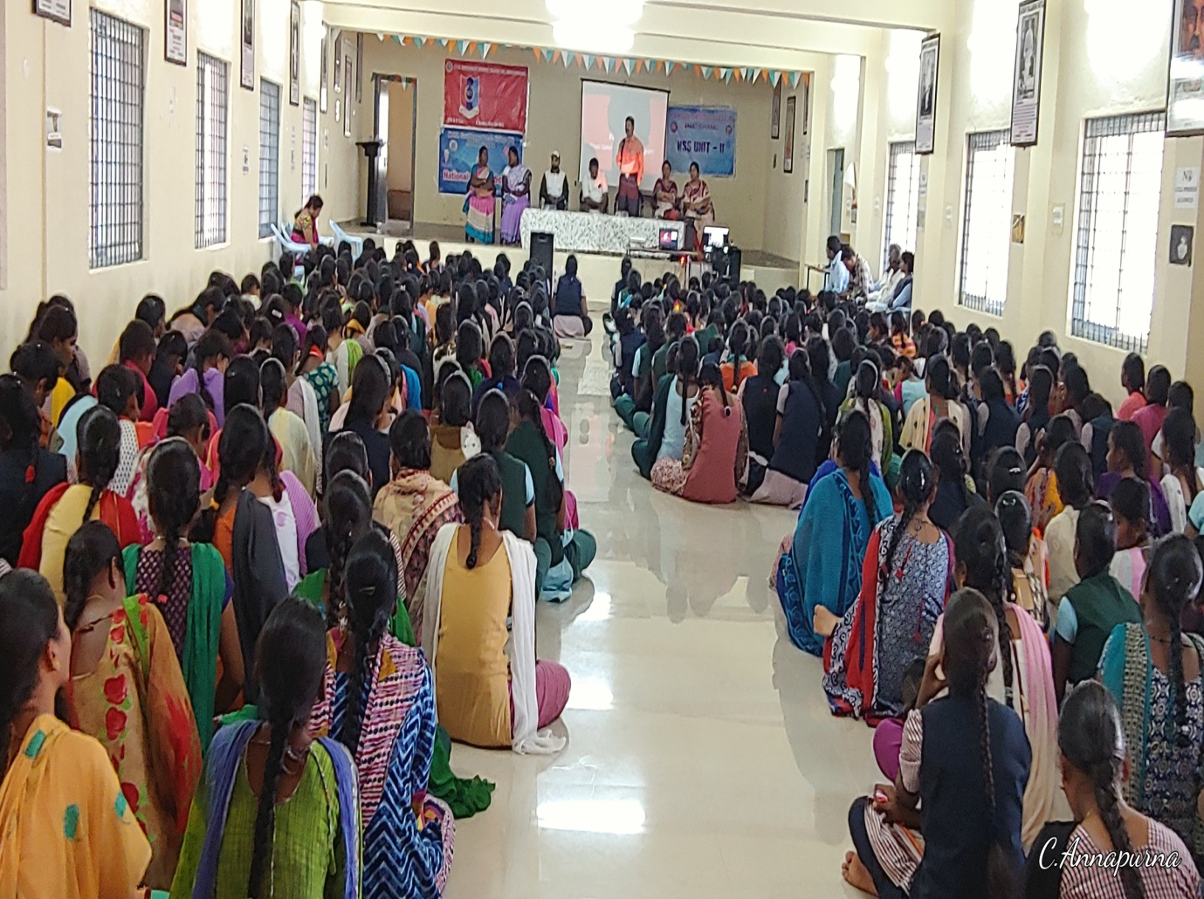
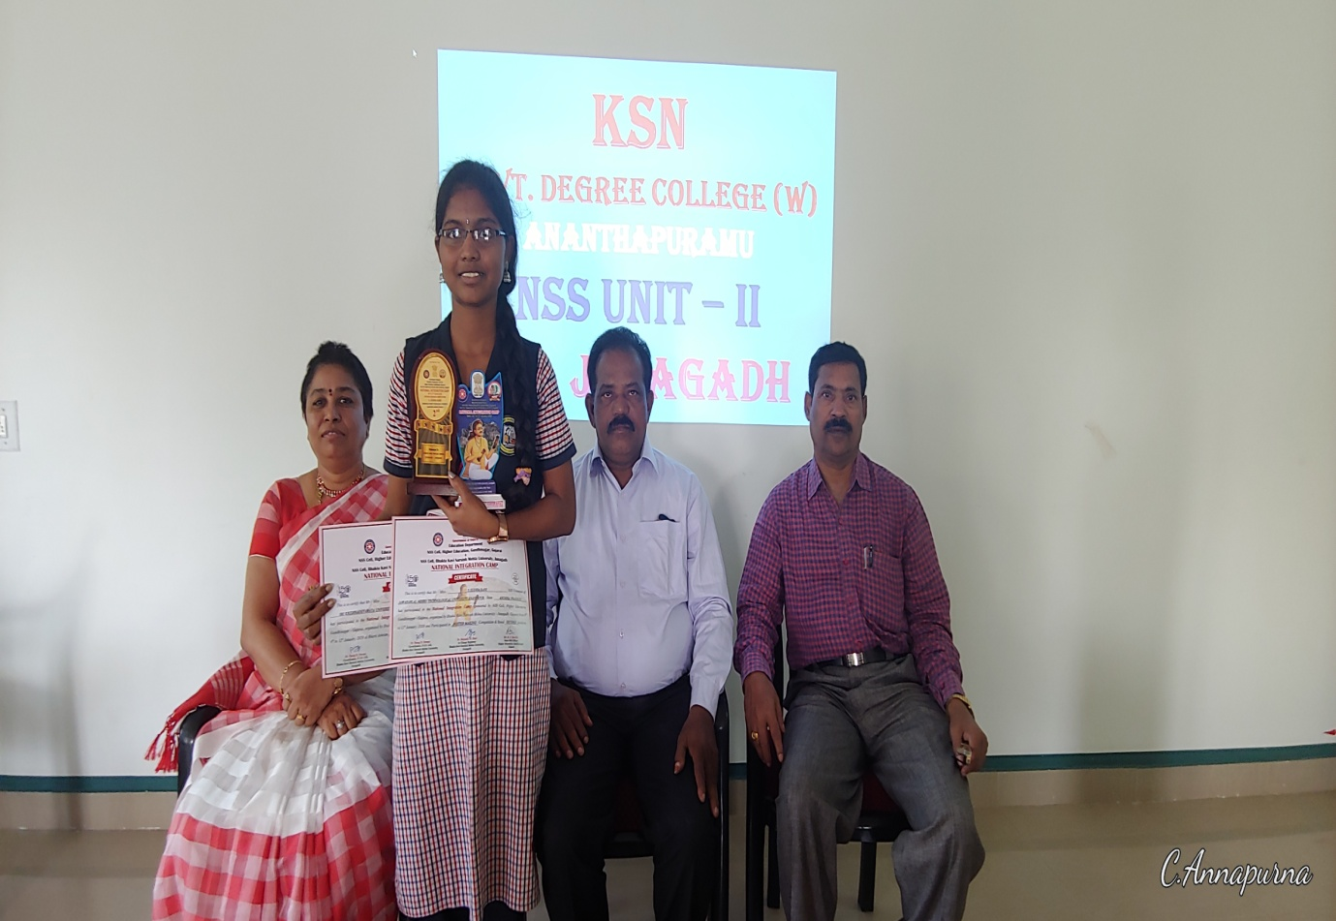
PARTICIPATION IN THE YOUTH FESTIVAL ON 22/01/2020
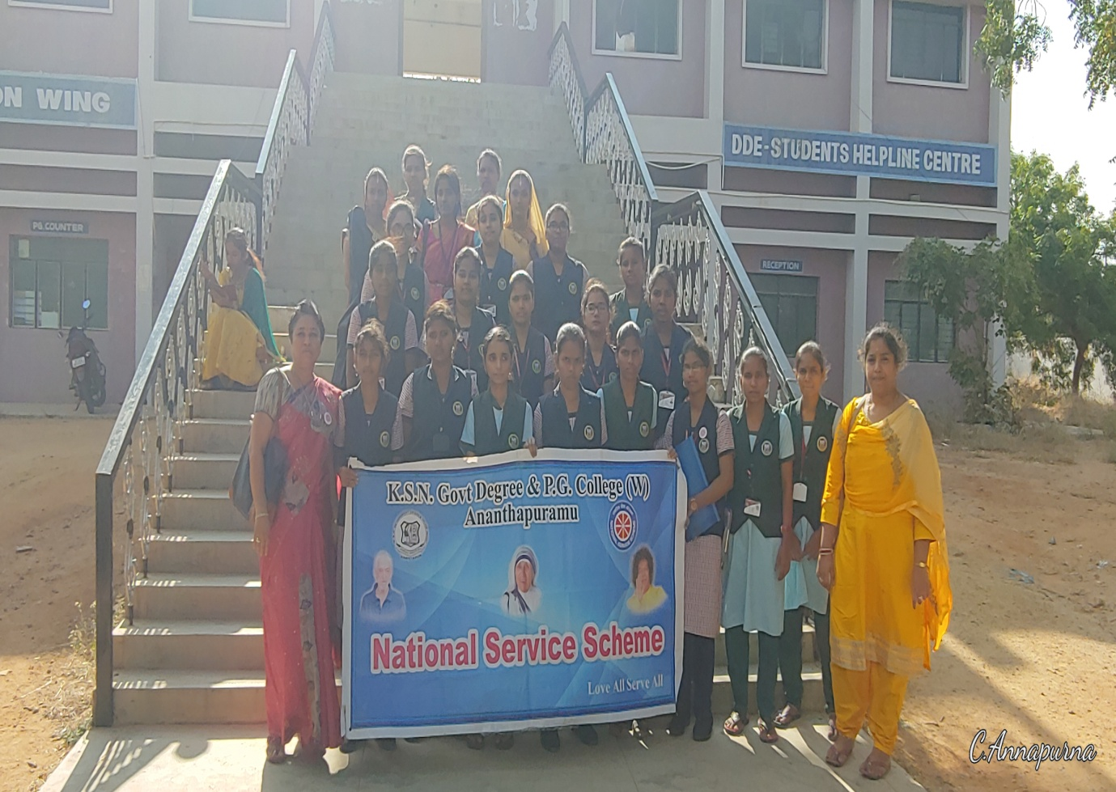
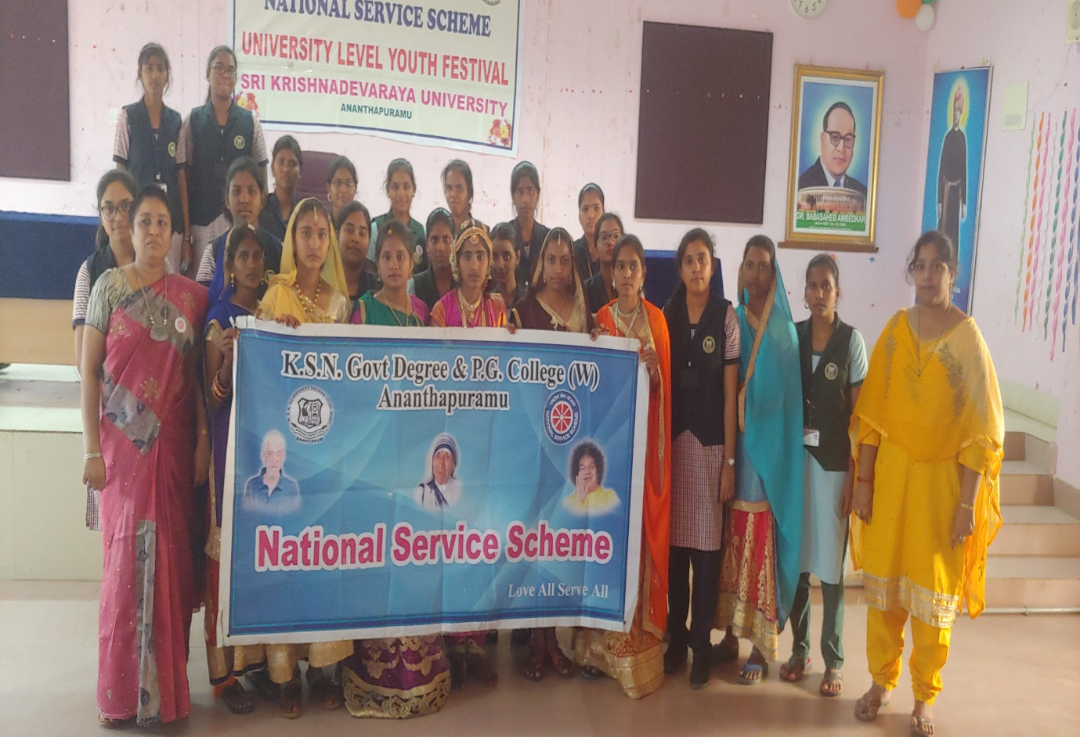
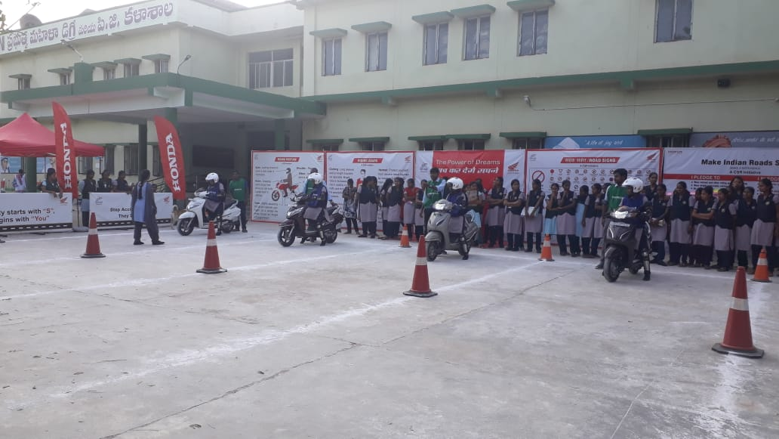
CELEBRATED IN NATIONAL GIRL CHILD ON 24.01.2020
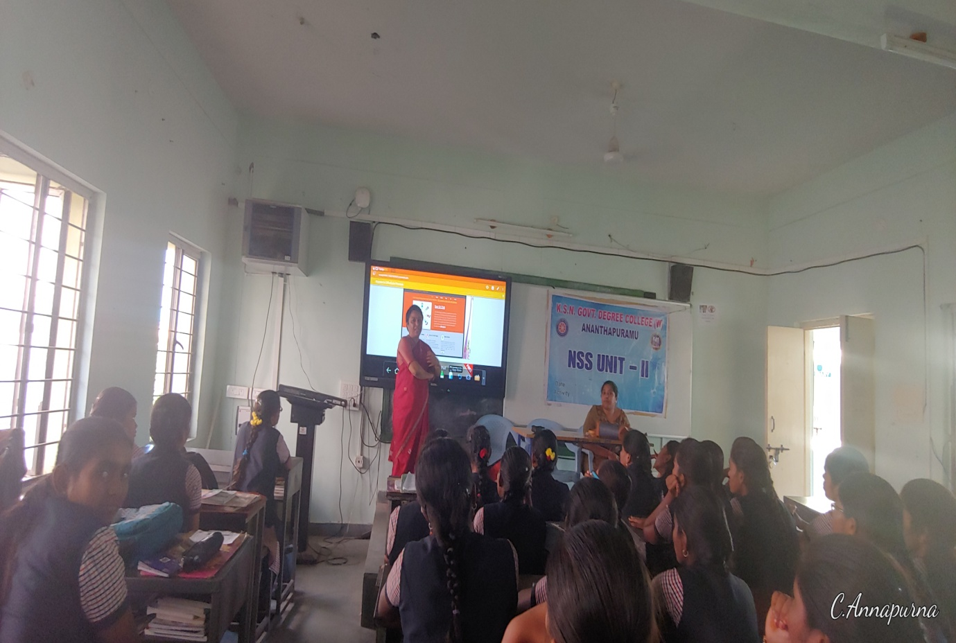
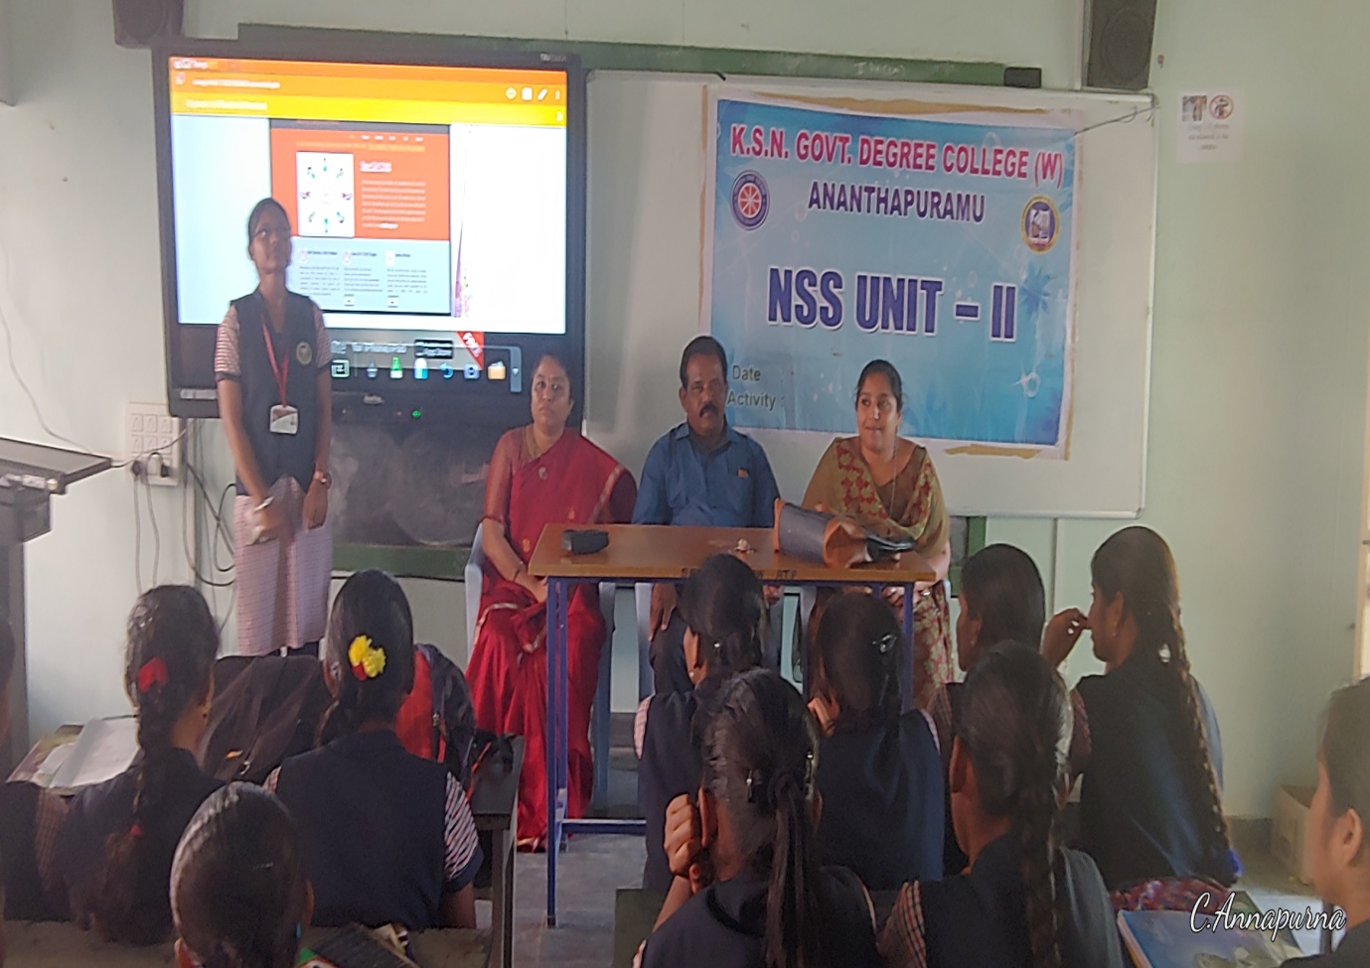
PARTICIPATED IN NATIONAL VOTERS’ DAY ON 25.01.2020
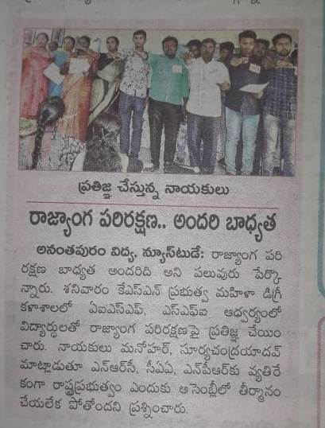
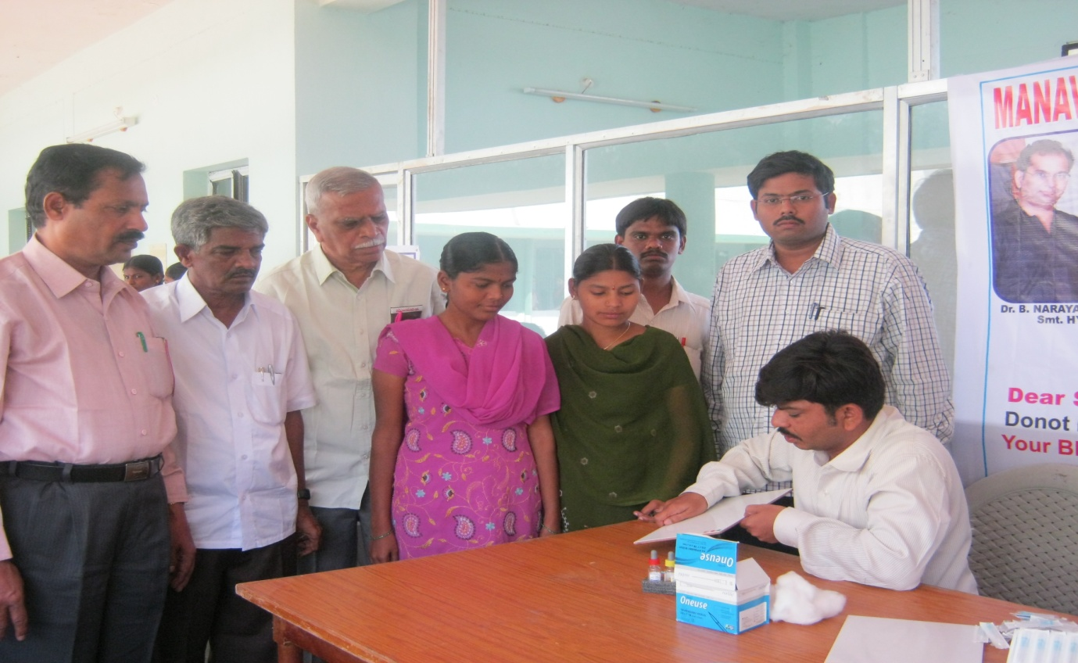
PARTICIPATED IN BLOOD DETERMINATION CAMP CONDUCTED BY RED RIBBON CLUB ON 06.02.2020
